7.1 VERBOS REFLEXIVOS
A reflexive verb is used to indicate that the subject does something to or for himself or herself. In other words, it “reflects” the action of the verb back to the subject. Reflexive verbs always use reflexive pronouns. ME, TE, SE, NOS, OS, SE.
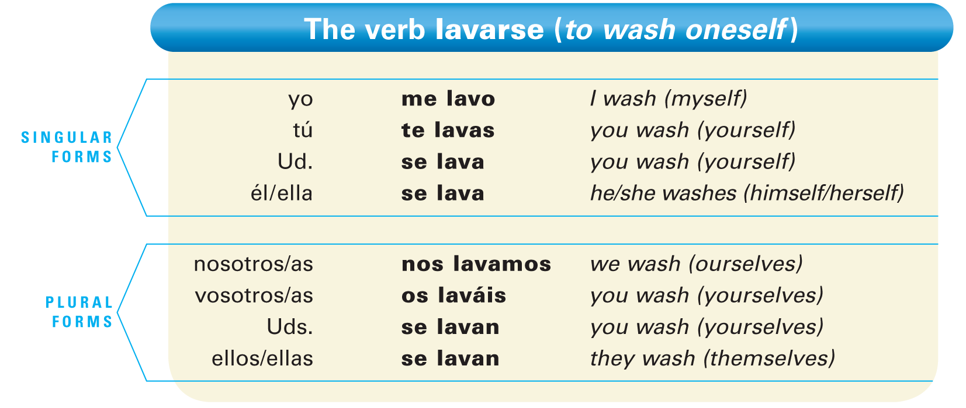
- The pronoun se attached to an infinitive identifies the verb as reflexive: lavarse.
- When a reflexive verb is conjugated, the reflexive pronoun agrees with the subject.
Like object pronouns, reflexive pronouns generally appear before a conjugated verb. With infinitives and present participles, they may be placed before the conjugated verb or attached to the infinitive or present participle. 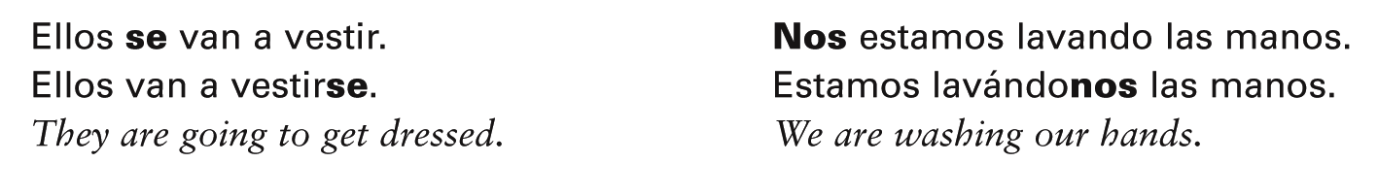
- ¡Atención! When a reflexive pronoun is attached to a present participle, an accent mark is added to maintain the original stress.
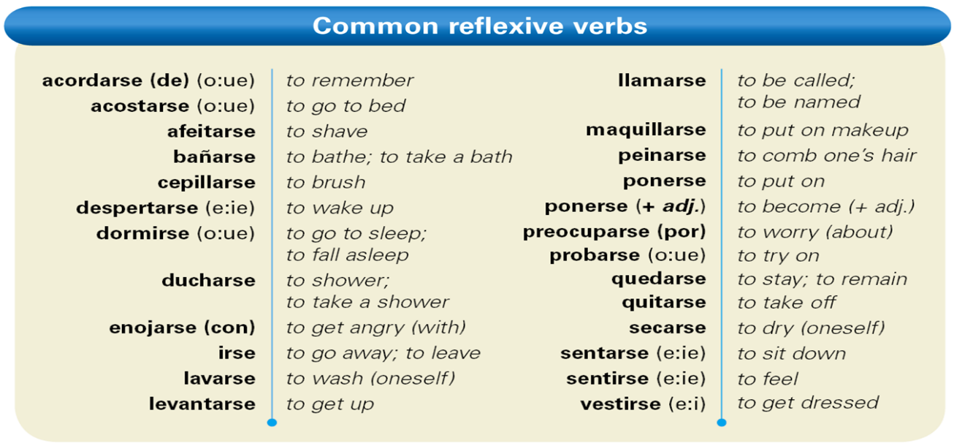
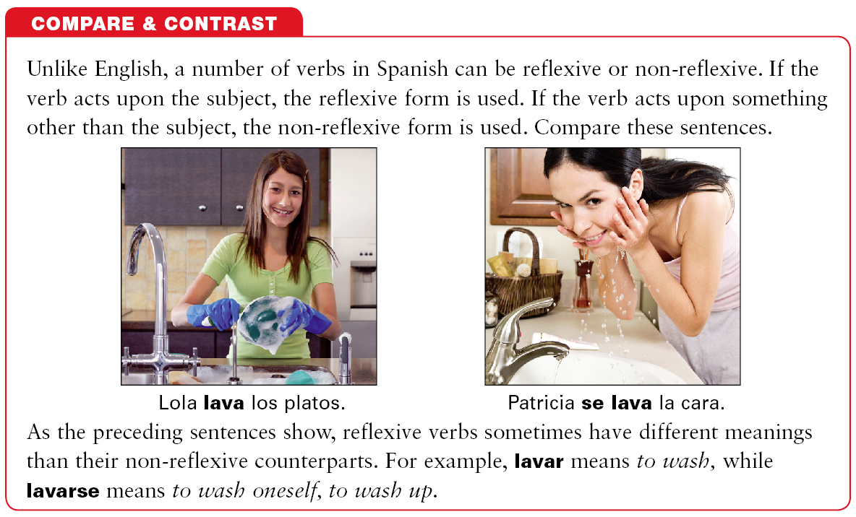
- ¡Atención! Parts of the body or clothing are generally not referred to with possessives, but with articles.

7.2 PALABRAS INDEFINIDAS Y NEGATIVAS
Indefinite words refer to people and things that are not specific, for example, someone or something. In Spanish, indefinite words have corresponding negative words, which are opposite in meaning. 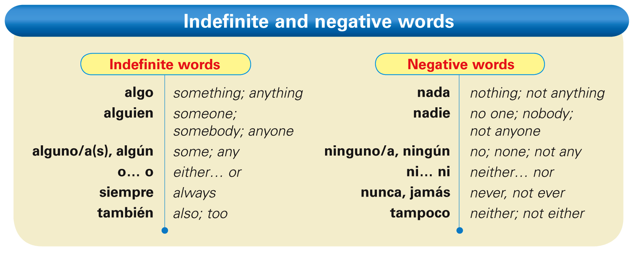
- There are two ways to form negative sentences in Spanish. You can place the negative word before the verb, or you can place no before the verb and the negative word after.
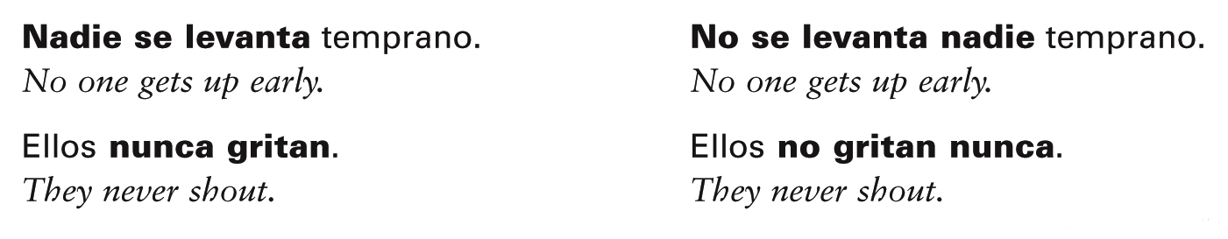
- Because they refer to people, alguien and nadie are often used with the personal a. The personal a is also used before alguno/a, algunos/as, and ninguno/a when these words refer to people and they are the direct object of the verb.
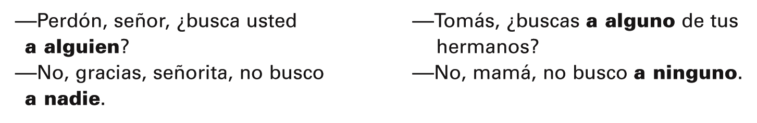
- ¡Atención! Before a masculine, singular noun, alguno and ninguno are shortened to algún and ningún.
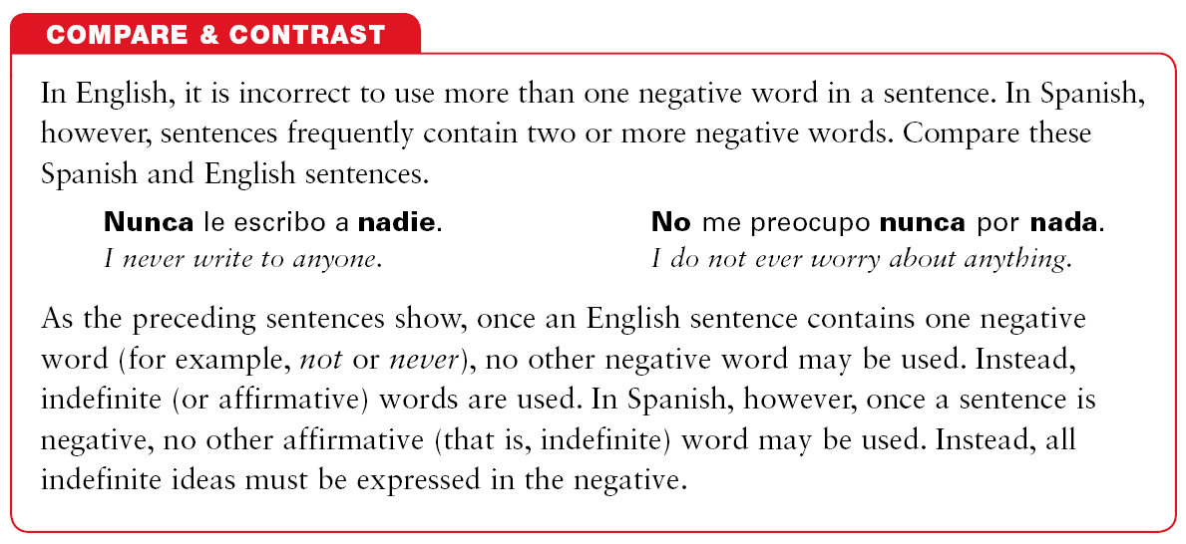
- Pero is used to mean but. The meaning of sino is but rather or on the contrary. It is used when the first part of the sentence is negative and the second part contradicts it.
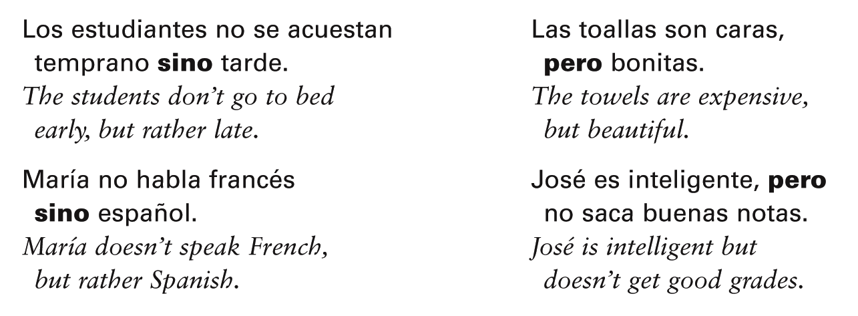

7.3 PRETÉRITO DE SER, IR, DAR, Y VER
In Lección 6, you learned how to form the preterite tense of regular -ar, -er, and -ir verbs. The following chart contains the preterite forms of ser (to be) and ir (to go). Since these forms are irregular, you will need to memorize them. 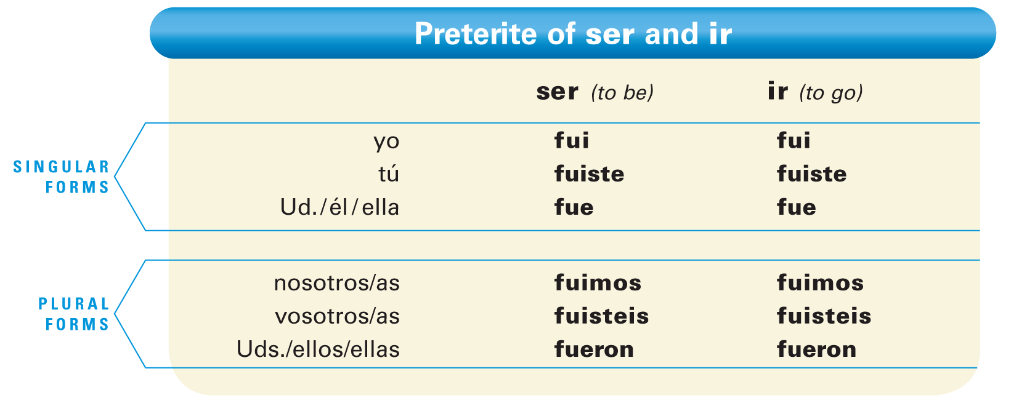
- Since the preterite forms of ser and ir are identical, context clarifies which of the two verbs is being used.
- Ver and dar use the regular endings in the preterite, but none of their forms have an accent.
- dar --------- di, diste, dio, dimos, disteis, dieron
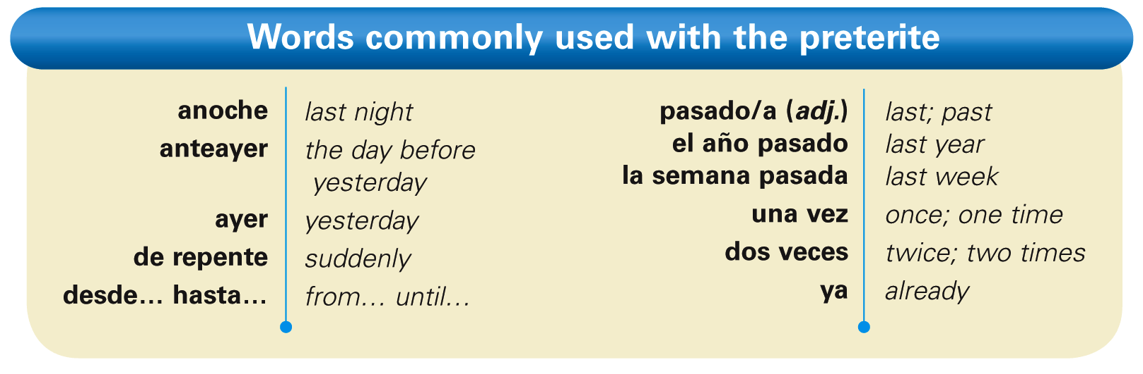
- Acabar de + [infinitive] is used to say that something has just occurred. Note that acabar is in the present tense in this construction.
7.4 VERBOS QUE SE CONJUGAN COMO EL VERBO GUSTAR
In Lección 2, you learned how to express preferences with gustar. You will now learn more about the verb gustar and other similar verbs. Observe these examples. 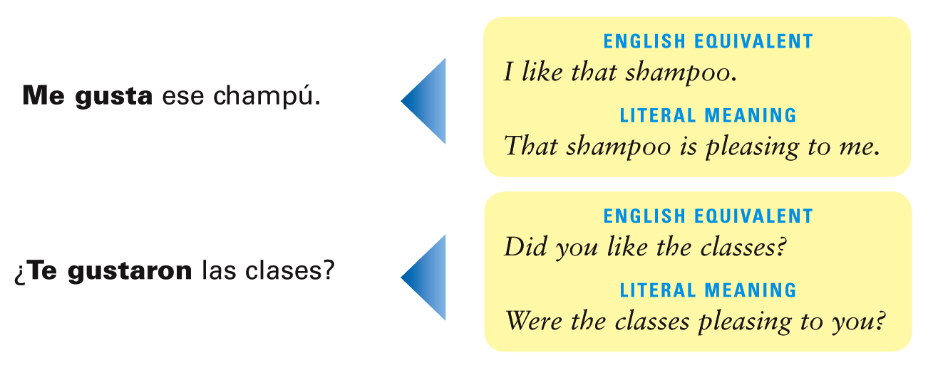
- As the examples show, constructions with gustar do not have a direct equivalent in English. The literal meaning of this construction is to be pleasing to (someone), and it requires the use of an indirect object pronoun.
- In the diagram above, observe how in the Spanish sentence the object being liked (ese champú) is really the subject of the sentence.
The person who likes the object, in turn, is an indirect object because it answers the question: To whom is the shampoo pleasing?
- Other verbs in Spanish are used in the same way as gustar. Here is a list of the most common ones.
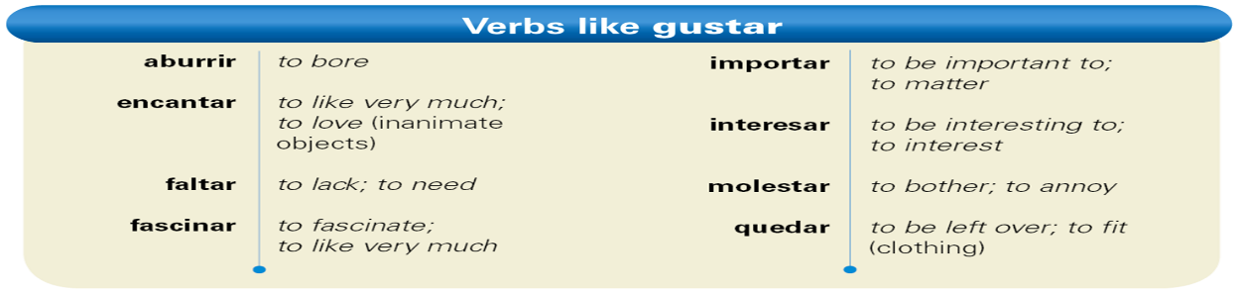
- ¡Atención! Faltar expresses what is lacking or missing.
Me falta una página.
I’m missing one page.
- Quedar expresses how much of something is left.
Nos quedan tres pesos.
We have three pesos left.
- ¡Atención! (cont.) Quedar also means to fit. It’s also used to tell how something looks (on someone).
Estos zapatos me quedan bien.
These shoes fit me well.
Esa camisa te queda muy bien.
That shirt looks good on you.
- The most commonly used verb forms with gustar and similar verbs are the third person (singular and plural). When the object or person being liked is singular, the singular form (gusta/molesta, etc.) is used. When two or more objects or persons are being liked, the plural form (gustan) is used. Observe the following diagram:
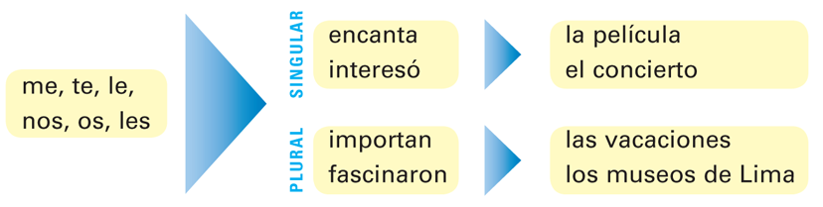
- To express what someone likes or does not like to do, use an appropriate verb followed by an infinitive. The singular form is used even if there is more than one infinitive.
- As you have already learned, the construction a + [pronoun] (a mí, a ti, a usted, a él, etc.) is used to clarify or to emphasize who is pleased, bored, etc. The construction a + [noun] can also be used before the indirect object pronoun to clarify or to emphasize who is pleased.
- ¡Atención! Mí (me) has an accent mark to distinguish it from the possessive adjective mi (my).

