GUÍA DE ESTUDIO DE LA LECCIÓN 4.

a menos que
alegrarse (de)
el animal
antes (de) que
el árbol
el ave, el pájaro
el bosque (tropical)
el calentamiento global
el cambio climático
cazar
el cielo
con tal (de) que
la conservación
conservar
la contaminación (del aire; del agua)
contaminar
controlar
el cráter
(no) creer
cuando
cuidar
de aluminio
de plástico
de vidrio
la deforestación
dejar de (+ inf.)
desarrollar
descubrir
el desierto
después de que
destruir
(no) dudar
la ecología
el/la ecologista
ecologista
el ecoturismo
en caso (de) que
en cuanto
la energía (nuclear, solar)
el envase
(no) es cierto
es extraño
es imposible
es improbable
es obvio
(no) es posible
(no) es probable
es ridículo
(no) es seguro
es terrible
es triste
es una lástima
(no) es verdad
esperar
estar afectado/a (por)
estar contaminado/a
la estrella
evitar
la extinción
la fábrica
la flor
el gato
el gobierno
hasta que
la hierba
el lago
la lata
la ley
la luna
el medio ambiente
mejorar
la naturaleza
(no) negar (e:ie)
no cabe duda de
no hay duda de
la nube
ojalá (que)
para que
el peligro
el perro
el pez (sing.), los peces (pl.)
la piedra
la planta
la (sobre)población
proteger
puro/a
el reciclaje
reciclar
recoger
el recurso natural
reducir
renovable
resolver (o:ue)
respirar
el río
la selva, la jungla
el sendero
sentir (e:ie)
sin que
el sol
la solución
tan pronto como
temer
la tierra
la vaca
el valle
el volcán

4.1 THE SUBJUNCTIVE WITH VERBS OF EMOTION
In the previous lesson, you learned how to use the subjunctive with expressions of will and influence. You will now learn how to use the subjunctive with verbs and expressions of emotion.
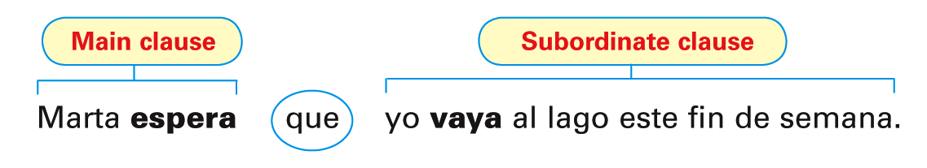
- When the verb in the main clause of a sentence expresses an emotion or feeling such as hope, fear, joy, pity, or surprise, the subjunctive is required in the subordinate clause.
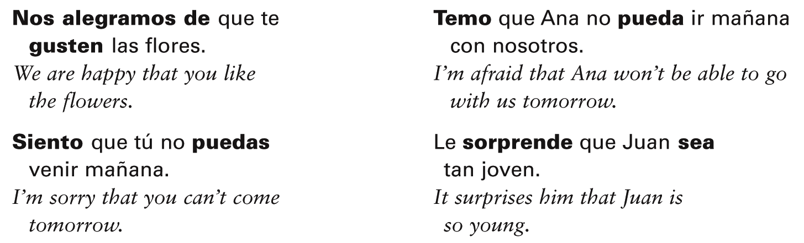
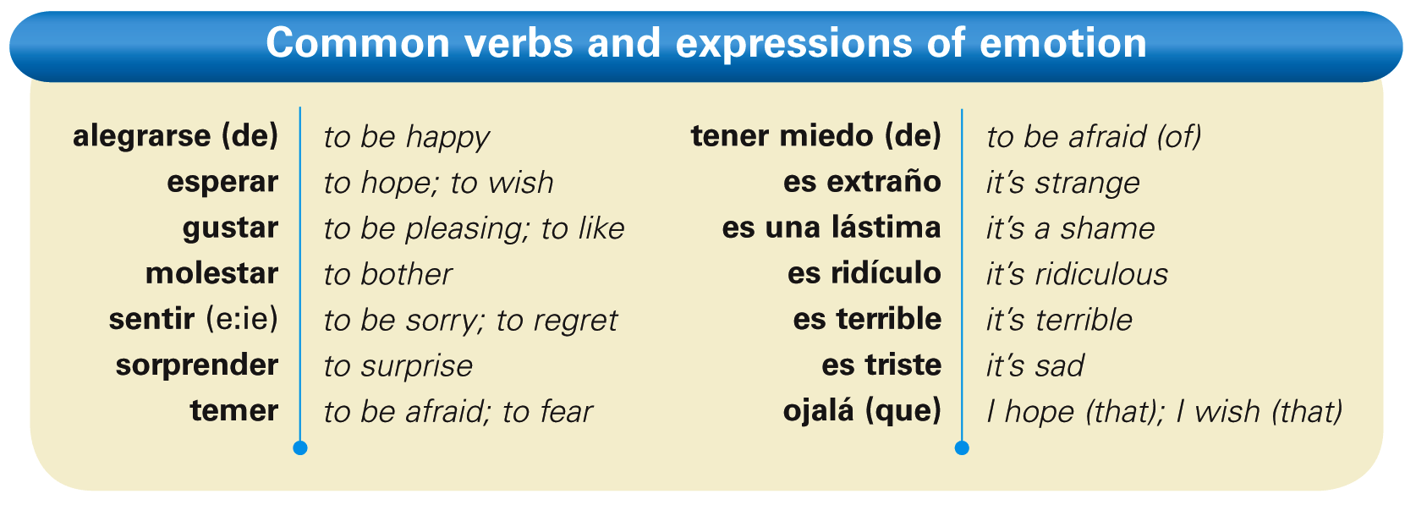
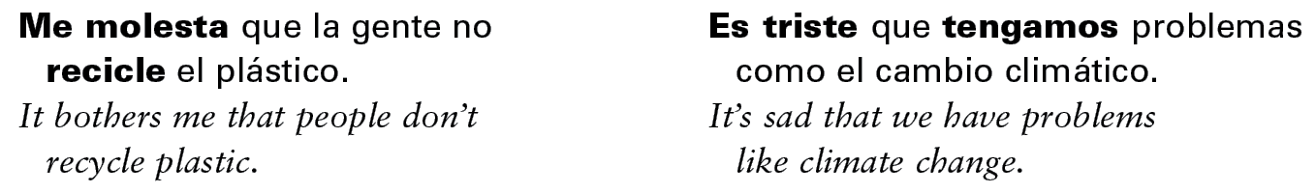
- As with expressions of will and influence, the infinitive, not the subjunctive, is used after an expression of emotion when there is no change of subject. Compare these sentences.
- The expression ojalá (que) means I hope or I wish, and it is always followed by the subjunctive. Note that the use of que with this expression is optional.
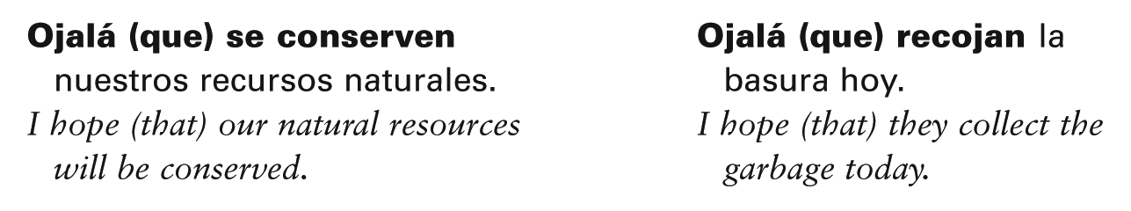
Completa las oraciones con las formas correctas de los verbos.
- Ojalá que ellos __________ (descubrir) nuevas formas de energía.
- Espero que Ana nos ________ (ayudar) a recoger la basura en la carretera.
- Es una lástima que la gente no ________ (reciclar) más.
- Esperamos ________ (proteger) el aire de nuestra comunidad.
- Me alegro de que mis amigos ________ (querer) conservar la naturaleza.
- Espero que tú ________ (venir) a la reunión (meeting) del Club de Ecología.
- Es malo ________ (contaminar) el medio ambiente.
- A mis padres les gusta que nosotros ________ (participar) en la reunión.
- Siento que nuestras ciudades ________ (estar) afectadas por la contaminación.
- Ojalá que yo ________ (poder) hacer algo para reducir la calentamiento global.

4.2 THE SUBJUNCTIVE WITH DOUBT, DISBELIEF, AND DENIAL.
- Just as the subjunctive is required with expressions of emotion, influence, and will, it is also used with expressions of doubt, disbelief, and denial.
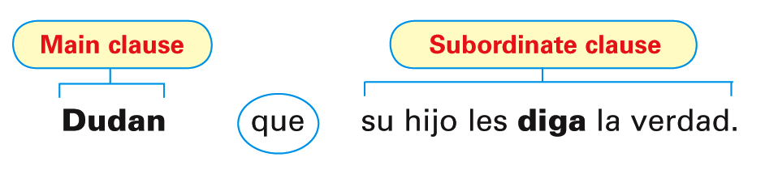
- The subjunctive is always used in a subordinate clause when there is a change of subject and the expression in the main clause implies negation or uncertainty.

- Here is a list of some common expressions of doubt, disbelief, or denial.

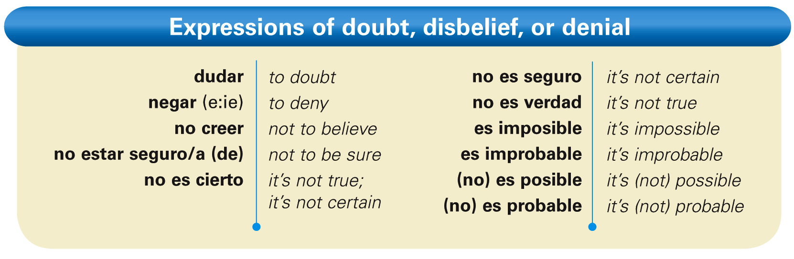
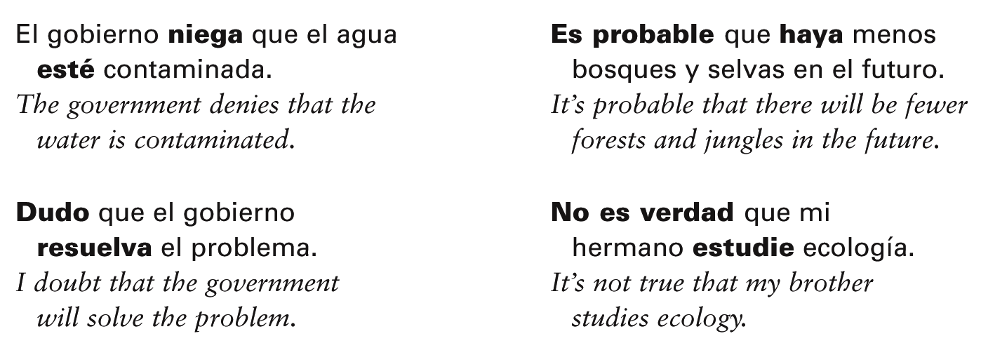
- The indicative is used in a subordinate clause when there is no doubt or uncertainty in the main clause. Here is a list of some expressions of certainty.
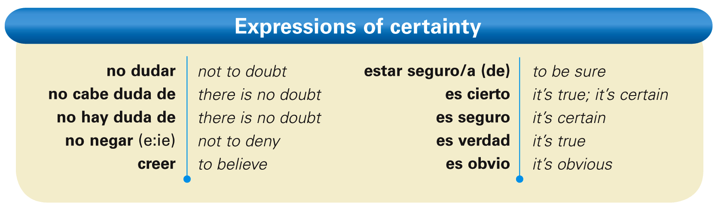
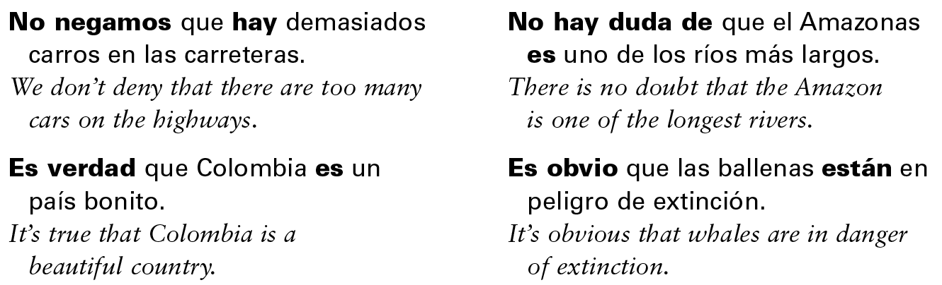
- In affirmative sentences, the verb creer expresses belief or certainty, so it is followed by the indicative. In negative sentences, however, when doubt is implied, creer is followed by the subjunctive.
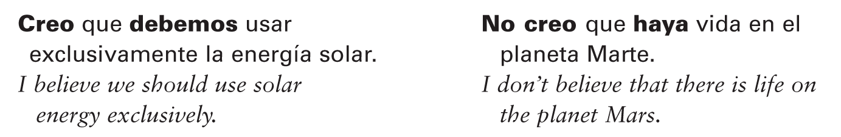
- The expressions quizás and tal vez are usually followed by the subjunctive
because they imply doubt about something.
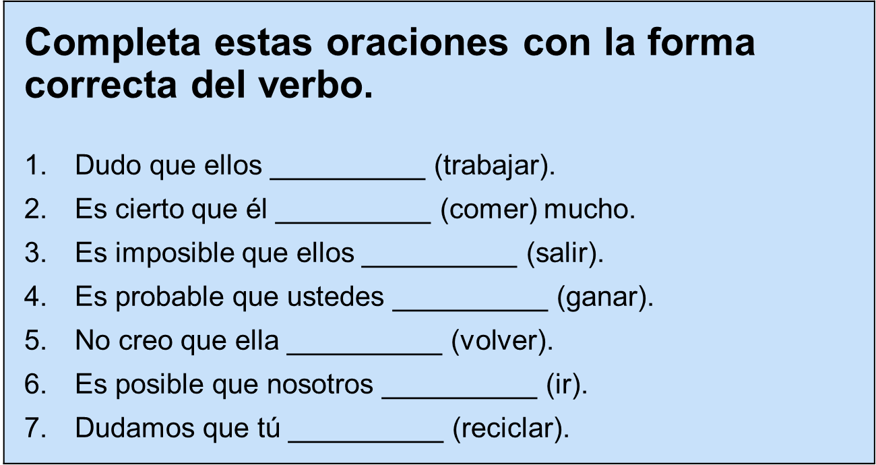
trabajen

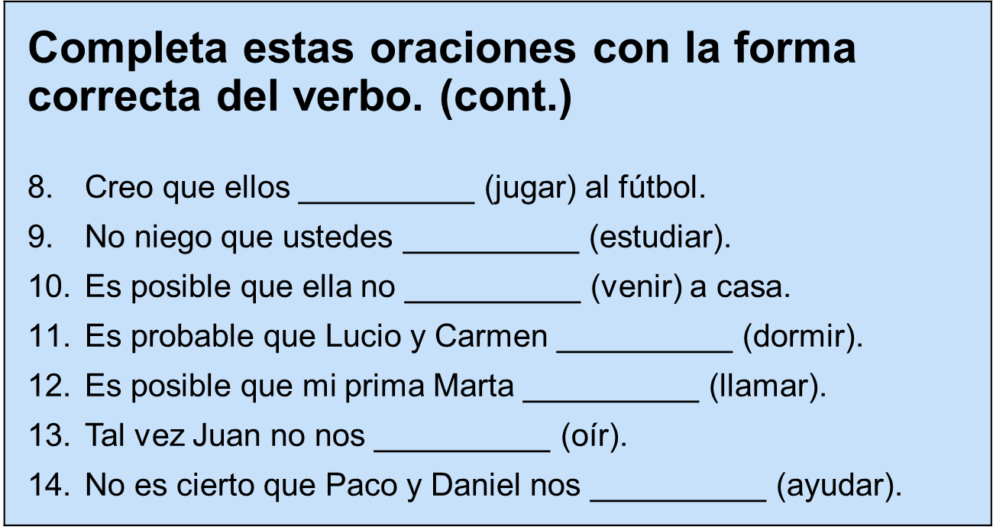

4.3 THE SUBJUNCTIVE WITH CONJUNCTIONS
- Conjunctions are words or phrases that connect other words and clauses in sentences. Certain conjunctions commonly introduce adverbial clauses, which describe how, why, when, and where an action takes place.
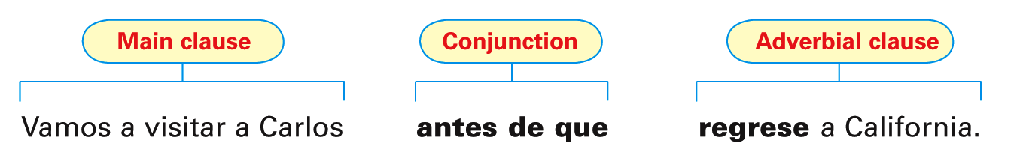
- With certain conjunctions, the subjunctive is used to express a hypothetical situation, uncertainty as to whether an action or event will take place, or a condition that may or may not be fulfilled.
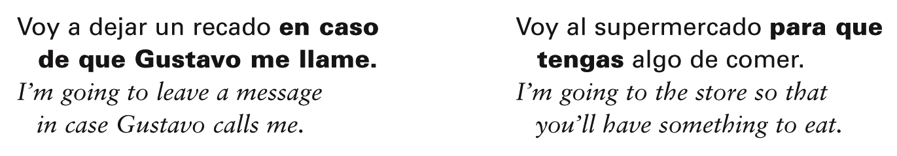
- Here is a list of the conjunctions that always require the subjunctive.
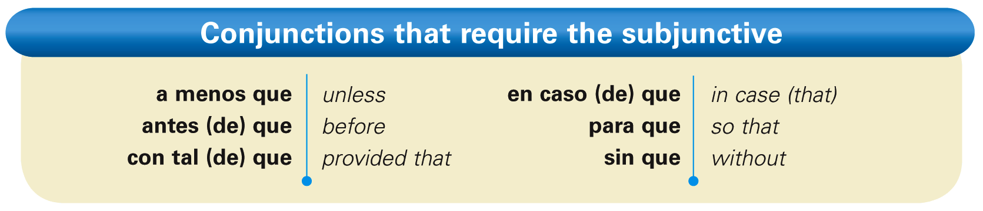
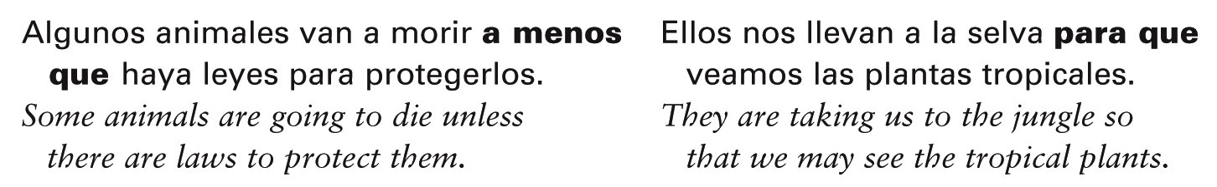
- The infinitive, not que + [subjunctive], is used after the prepositions antes de, para, and sin when there is no change of subject. ¡Atención! While you may use a present participle with the English equivalent of these phrases, in Spanish you cannot.
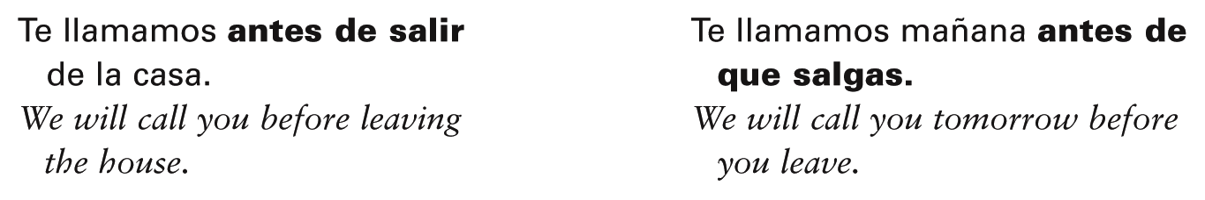
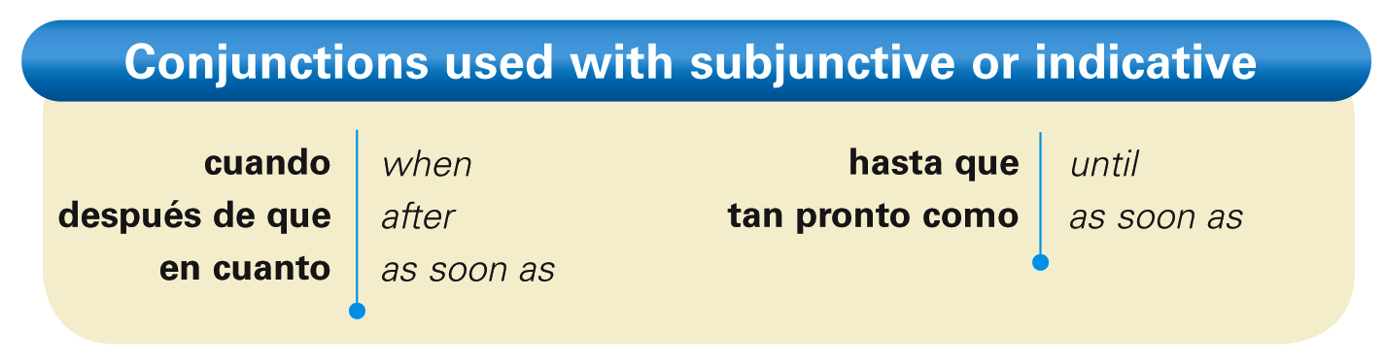
- With the conjunctions above, use the subjunctive in the subordinate clause if the main clause expresses a future action or command.

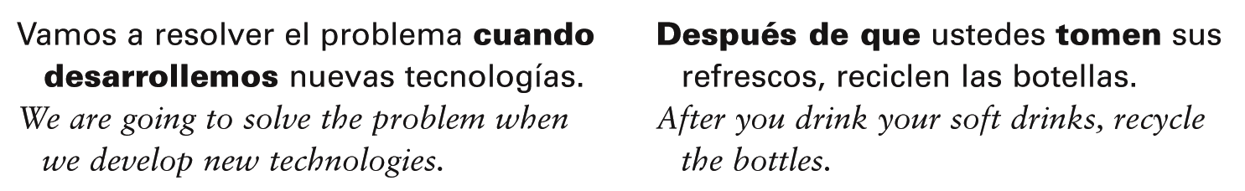
- With these conjunctions, the indicative is used in the subordinate clause if the verb in the main clause expresses an action that habitually happens, or that happened in the past.
