GUÍA DE ESTUDIO DE LA LECCIÓN 8

VOCABULARIO
el aceite | oil
el agua (mineral) | (mineral) water
el ajo | garlic
el almuerzo | lunch
editamargo | bitter
el arroz | rice
las arvejas | peas
el atún | tuna
el azúcar | sugar
la banana | banana
editel plátano | banana
la bebida | drink
el bistec | steak
editel caballero | gentleman, sir
el café | coffee
editcaliente | hot (temperature)
el/la camarero/a | waiter/waitress
los camarones | shrimp
la carne | meat
la carne de res | beef
la cebolla | onion
la cena | dinner
los cereales | cereal; grains
la cerveza | beer
el champiñón | mushroom
editlos champiñones/los hongos | mushrooms
editlos chícharos/los guisantes | peas
la chuleta (de cerdo) | (pork) chop
la comida | food; meal
como | like; as
delicioso/a | delicious
el desayuno | breakfast
el/la dueño/a | owner
editdulce | sweet
editel elote | corn
la ensalada | salad
los entremeses | hors d'oeuvres; appetizers
escoger | to choose
los espárragos | asparagus
editla fresa | strawberry
los frijoles | beans
las frutas | fruit
editlas galletas | cookies
editel gerente | manager
la hamburguesa | hamburger
editel helado / la nieve | ice cream
edithelado/frio | cold
el huevo | egg
el jamón | ham
el jugo (de fruta) | (fruit) juice
la langosta | lobster
la leche | milk
la lechuga | lettuce
el limón | lemon
editel limón | lime
el maíz | corn
la mantequilla | butter
la manzana | apple
editla manzana | apple
la margarina | margarine
editlos mariscos | seafood
los mariscos | shellfish
más de (+ number) | more than
más… que | more… than
la mayonesa | mayonnaise
editmayor | older
el/la mayor | the oldest
el/la mejor | the best
mejor | better
el melocotón | peach
editel durazno | peach
el/la menor | the youngest
editmenor | younger
menos de (+ number) | fewer than
menos… que | less… than
el menú | menu
merendar (e:ie) | to snack
editla merienda | snack
morir (o:ue) | to die
la naranja | orange
editlas nueces | pecans
el pan (tostado) | (toasted) bread
las papas/patatas (fritas) | (fried) potatoes; French fries
editel pastel / la torta | cake
el pavo | turkey
pedir (e:i) | to order (food)
editpedir | to ask for
peor | worse
el/la peor | the worst
la pera | pear
el pescado | fish
editpicante | spicy
la pimienta | black pepper
el plato (principal) | (main) dish
el pollo (asado) | (roast) chicken
probar (o:ue) | to taste; to try
el queso | cheese
recomendar (e:ie) | to recommend
el refresco | soft drink; soda
rico/a | tasty; delicious
saber (a) | to taste (like)
sabroso/a | tasty; delicious
la sal | salt
la salchicha | sausage
editla salchicha | hot dog
el salmón | salmon
el sándwich | sandwich
la sección de (no) fumar | (non) smoking section
servir (e:i) | to serve
la sopa | soup
tan… como | as… as
tanto… como | as much… as
tantos/as… como | as many… as
el té (helado) | (iced) tea
el tomate | tomato
editel jitomate | tomato
la uva | grape
las verduras | vegetables
el vinagre | vinegar
el vino (blanco/tinto) | (white/red) wine
el yogur | yogurt
la zanahoria | carrot

ESTRUCTURA 8.1 PRETERITE OF STEM-CHANGING VERBS
- As you learned in Lección 6, -ar and -er stem-changing verbs have no stem change in the preterite.
-Ir stem-changing verbs, however, do have a stem change. Study the following chart and observe where the stem changes occur.
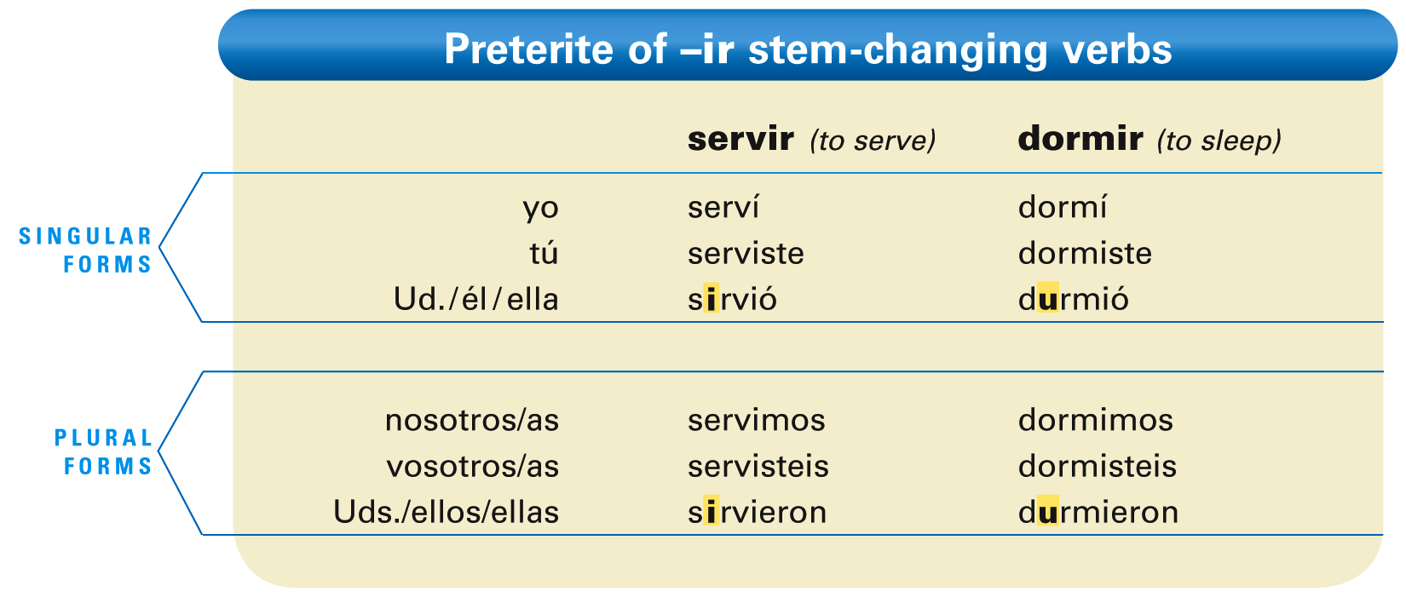
- Stem-changing -ir verbs, in the preterite only, have a stem change in the third-person singular and plural forms. The stem change consists of either e to i or o to u.
Cambia cada infinitivo al pretérito.
- Yo __________________________________________________________________________. (servir, dormir, pedir, preferir, repetir, seguir)
- Usted ________________________________________________________________________. (morir, conseguir, pedir, sentirse, servir, vestirse)
- Tú ___________________________________________________________________________. (conseguir, servir, morir, pedir, dormir, repetir)
- Ellas _________________________________________________________________________. (repetir, dormir, seguir, preferir, morir, servir)
- Nosotros ______________________________________________________________________. (seguir, preferir, servir, vestirse, pedir, dormirse)
- Ustedes ______________________________________________________________________. (sentirse, vestirse, conseguir, pedir, repetir, dormirse)
- Él ___________________________________________________________________________. (dormir, morir, preferir, repetir, seguir, pedir)

ESTRUCTURA 8.2 DOUBLE OBJECT PRONOUNS
- In Lecciones 5 and 6, you learned that direct and indirect object pronouns replace nouns and that they often refer to nouns that have already been referenced. You will now learn how to use direct and indirect object pronouns together. Observe the following diagram.
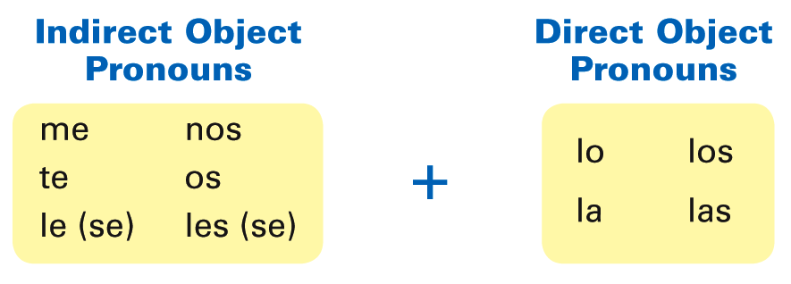
- When direct and indirect object pronouns are used together, the indirect object pronoun always precedes the direct object pronoun.
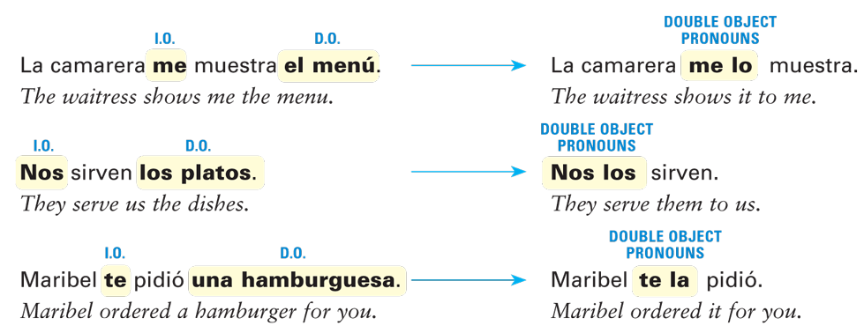
- In Spanish, two pronouns that begin with the letter l cannot be used together. Therefore, the indirect object pronouns le and les always change to se when they are used with lo, los, la, and las.
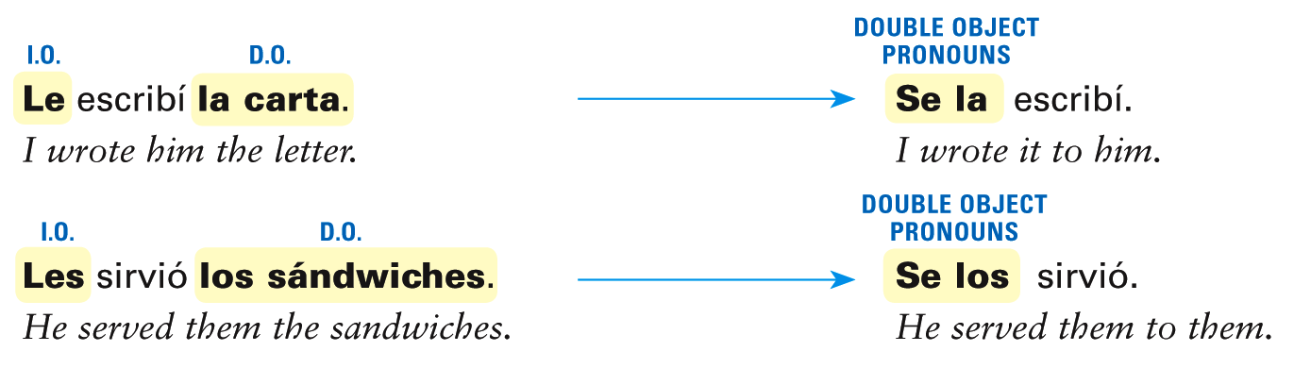

- Because se has multiple meanings, Spanish speakers often clarify to whom the pronoun refers by adding a usted, a él, a ella, a ustedes, a ellos, or a ellas.
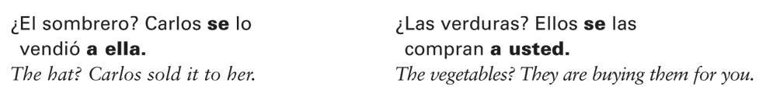- Double object pronouns are placed before a conjugated verb. With infinitives and present participles, they may be placed before the conjugated verb or attached to the end of the infinitive or present participle.
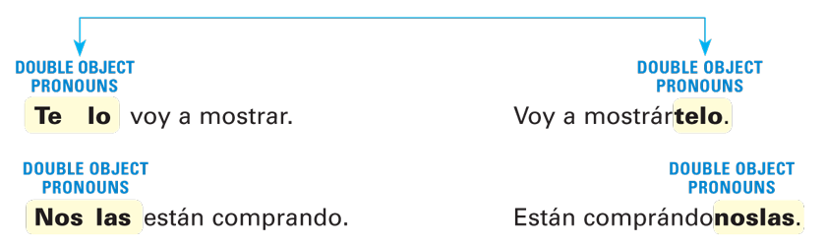
Mi abuelo me lo está leyendo. El camarero se los va a servir.
Mi abuelo está leyéndomelo. El camarero va a servírselos.
- As you can see above, when double object pronouns are attached to an infinitive or a present participle, an accent mark is added to maintain the original stress.
Escribe el pronombre de objeto directo o indirecto que falta en cada oración.
- ¿La ensalada? El camarero nos _____ sirvió.
- ¿El salmón? La dueña me _____ recomienda.
- ¿La comida? Voy a preparárte _____.
- ¿Las bebidas? Estamos pidiéndose _____.
- ¿Los refrescos? Te _____ puedo traer ahora.
- ¿Los platos de arroz? Van a servírnos _____ después.
Escribe el pronombre de objeto directo o indirecto que falta en cada oración. (cont.)
- ¿Puedes traerme tu plato? No, no _____ lo puedo traer.
- ¿Quieres mostrarle la carta? Sí, voy a mostrár _____ la ahora.
- ¿Les serviste la carne? No, no _____ la serví.
- ¿Vas a leerle el menú? No, no _____ lo voy a leer.
- ¿Me recomiendas la langosta? Sí, _____ la recomiendo.
- ¿Cuándo vas a prepararnos la cena? _____ la voy a preparar en una hora.

ESTRUCTURA 8.3 COMPARISONS: Both Spanish and English use comparisons to indicate which of two people or things has a lesser, equal, or greater degree of a quality.
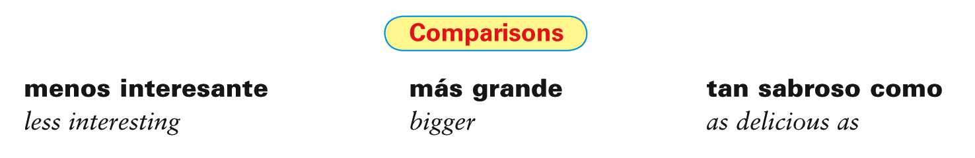
Comparisons of inequality: Comparisons of inequality are formed by placing más (more) or menos (less) before adjectives, adverbs, and nouns and que (than) after them.
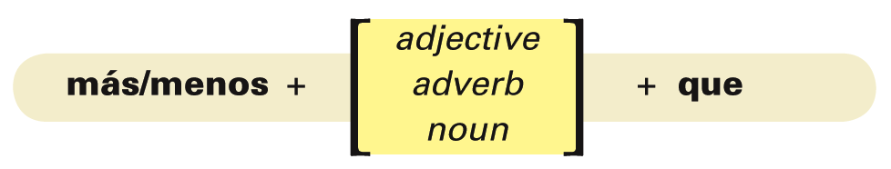
- ¡Atención! Note that while English has a comparative form for short adjectives (taller), such forms do not exist in Spanish (más alto).
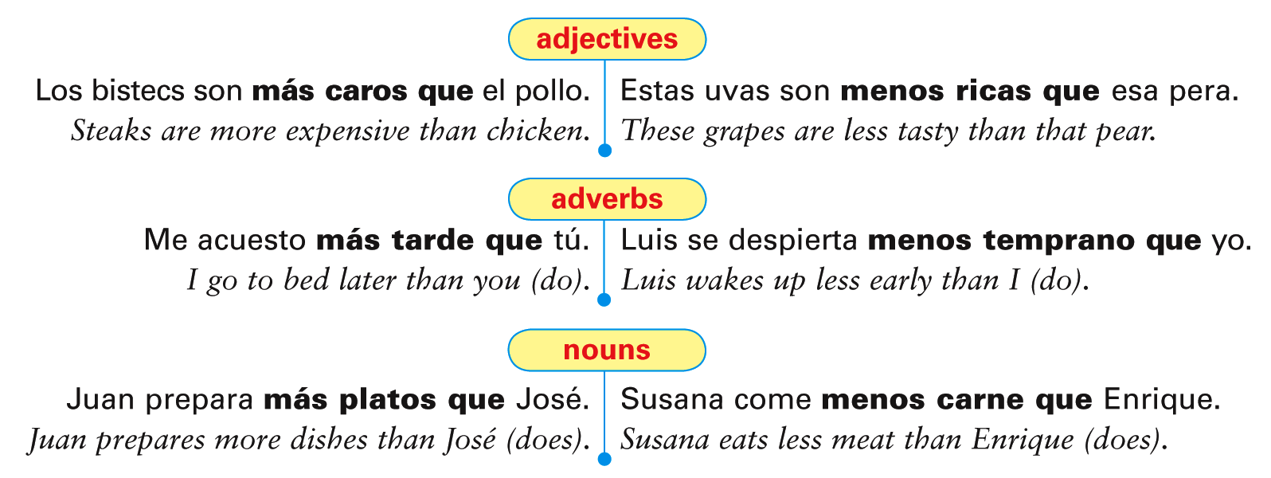
- When the comparison involves a numerical expression, de is used before the number instead of que.
- With verbs, this construction is used to make comparisons of inequality.
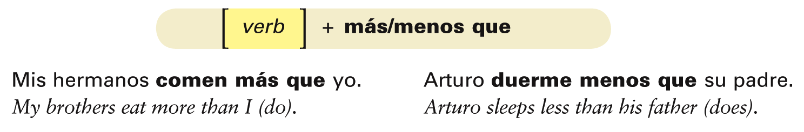
Comparisons of equality: This construction is used to make comparisons of equality.
- ¡Atención! Note that unlike tan, tanto acts as an adjective and therefore agrees in number and gender with the noun it modifies.
- Tan and tanto can also be used for emphasis, rather than to compare, with these meanings: tan so, tanto so much, tantos/as so many.
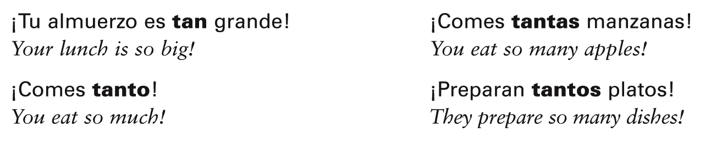
- Comparisons of equality with verbs are formed by placing tanto como after the verb. Note that in this construction tanto does not change in number or gender.
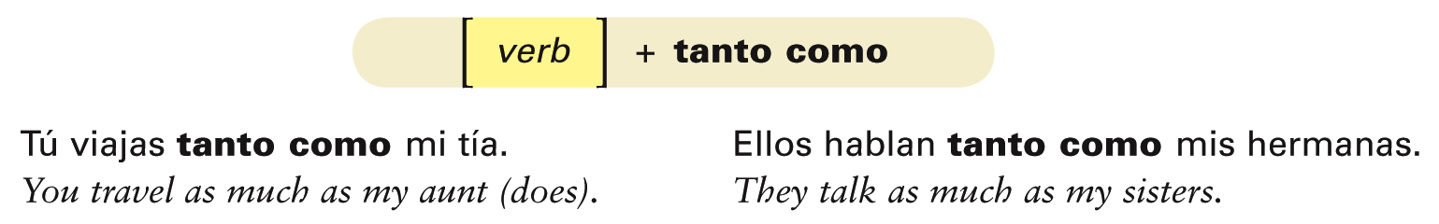
Irregular comparisons: Some adjectives have irregular comparative forms.
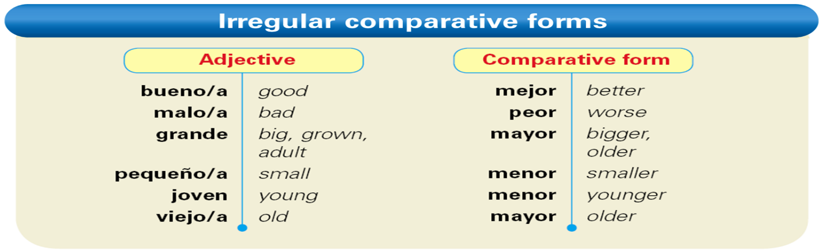
- When grande and pequeño/a refer to age, the irregular comparative forms, mayor and menor, are used. However, when these adjectives refer to size, the regular forms, más grande and más pequeño/a, are used.
The adverbs bien and mal have the same irregular comparative forms as the adjectives bueno/a and malo/a.
Escribe el equivalente de las palabras en inglés.
- Ernesto mira más televisión _____ (than) Alberto.
- Tú eres _____ (less) simpático que Federico.
- La camarera sirve _____ (as much) carne como pescado.
- Conozco _____ (more) restaurantes que tú.
- No estudio _____ (as much as) tú.
- ¿Sabes jugar al tenis tan bien _____ (as) tu hermana?
- ¿Puedes beber _____ (as many) refrescos como yo?
- Mis amigos parecen _____ (as) simpáticos como ustedes.

ESTRUCTURA 8.4 SUPERLATIVES: Both English and Spanish use superlatives to express the highest or lowest degree of a quality.
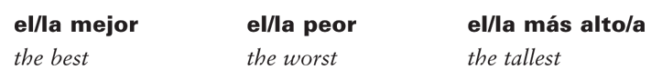
- This construction is used to form superlatives. Note that the noun is always preceded by a definite article and that de is equivalent to the English in or of.
- The noun can be omitted if the person, place, or thing referred to is clear.
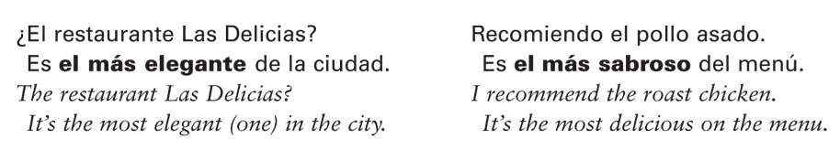
- ¡Atención! While más alone means more, after el, la, los, or las, it means most. Likewise, menos can mean less or least.
Es el café más rico del país. It’s the most delicious coffee in the country.
Es el menú menos caro de todos éstos. It is the least expensive menu of all of these.
- Here are some irregular superlative forms.
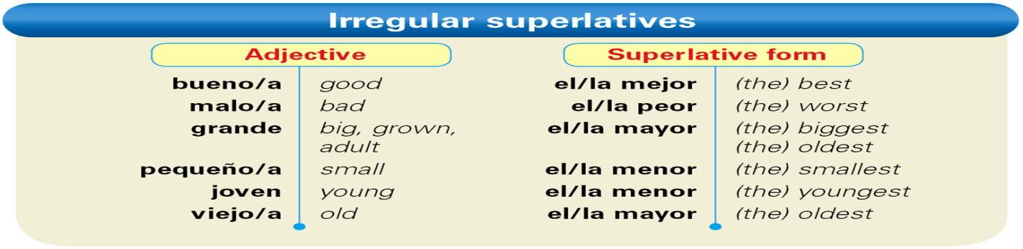
- The absolute superlative is equivalent to extremely, super, or very. To form the absolute superlative of most adjectives and adverbs, drop the final vowel, if there is one, and add -ísimo/a(s).
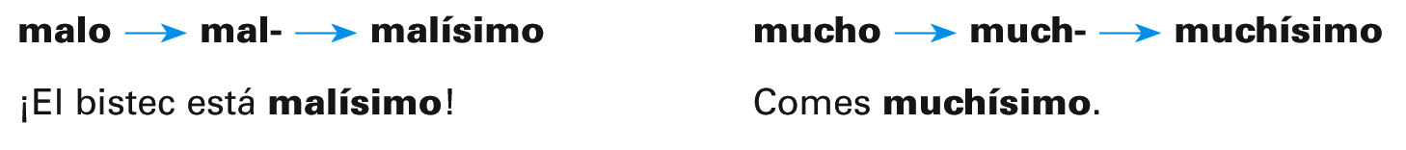
- Note these spelling changes.
Escribe el equivalente de las palabras en inglés.
- Marisa es _________________________________________ (the most intelligent) de todas.
- Ricardo y Tomás son _________________________________ (the least boring) de la fiesta.
- Miguel y Antonio son ____________________________ (the worst) estudiantes de la clase.
- Mi profesor de biología es ________________________________ (the oldest) de la escuela.

