GUÍA DE ESTUDIO DE LA LECCIÓN 3

VOCABULARIO
las afueras suburbs; outskirts
el alquiler rent payment
el ama de casa housekeeper,
caretaker
el barrio neighborhood
el edificio de apartamentos/ apartment departamentos building
el/la vecino/a neighbor
la vivienda housing
alquilar to rent
mudarse to move (from
one house to another)
el altillo/ático/desván attic
el balcón balcony
la cocina kitchen
el comedor dining room
el dormitorio/la recámara bedroom
el cuarto/aposento
la entrada entrance
la escalera stairs; stairway
el garage/la cochera garage
el jardín garden; yard
la oficina office
el pasillo hallway
el patio patio, yard
la sala living room
el sótano basement, cellar
la alfombra carpet, rug
la almohada pillow
el armario closet
el cartel poster
la cómoda chest of drawers
las cortinas curtains
el cuadro picture
el estante/el librero bookshelves;
bookcase
la lámpara lamp
la luz light; electricity
la manta/la cobija blanket
la mesita end table

la mesita de noche night stand
los muebles furniture
la pared wall
la pintura painting; picture
el sillón armchair
el sofa couch; sofa
la cafeteria coffee maker
la estufa stove
el congelador freezer
el electrodoméstico electric appliance
el horno oven
el horno de microondas microwave oven
la lavadora washing machine
el lavaplatos dishwasher
el refrigerador refrigerator
la secadora clothes dryer
la tostadora toaster
la copa wineglass; goblet
la cuchara spoon (table or large)
el cuchillo knife
el plato plate
la servilleta napkin
la taza cup
el tenedor fork
el vaso glass
arreglar to neaten; to straighten up
barrer el suelo to sweep the flor
cocinar to cook
ensuciar to get something dirty
hacer la cama to make the bed
hacer quehaceres domésticos to do household chores
lavar to wash
lavar el suelo to wash the floor
lavar/fregar los platos to wash the dishes
limpiar la casa to clean the house
pasar la aspiradora to vacuum
planchar to iron
poner la mesa to set the table
quitar la mesa to clear the table
quitar el polvo to dust
sacar la basura to take out the trash
sacudir los muebles to dust the furniture
aconsejar to advise
insister (en) to insist (on)
mandar to order
recomendar to recommend
rogar to beg; to plead
sugerir to suggest
es bueno que… it’s good that…
es importante que… it’s important that
es malo que… it’s bad that…
es mejor que… it’s better that…
es necesario que… it’s necessary
that…
es urgente que… it’s urgent that…
antes de que… before…
PRONOMBRES RELATIVOS “QUE”: Remember, pronouns are words that refer to a noun. Relative pronouns are called “relative” because they are “related” to a noun that has previously been stated.
One way to view relative pronouns is to recognize that they combine two sentences that share a common noun. In the following example, the common noun is “milk” or “leche.”
¿Dónde está la leche? Compraste leche.
Where is the milk? You bought milk.
¿Dónde está la leche que compraste?
Where is the milk that you bought?

Another way to view relative pronouns is to recognize that they are used to introduce a clause that modifies a noun. In the following example, the clause “I finished last night” modifies the noun “book.”
Terminé el libro anoche. El libro es muy extensor.
I finished the book last night. The book is very long.
El libro que terminé anoche es muy extenso.
The book that I finished last night is very long.

The most common relative pronoun, and the one used in the previous two examples is “que”. It can be used to refer to both persons and things, in either the subject or the object position. “Que” is the Spanish equivalent of the English words: who, whom, which, and that.
El hombre que es pobre … (person, subject) Los libros que son extensos … (thing, subject)
The man who is poor … The books which are long …
La señorita que conocí … (person, object) La carta que leíste … (thing, object)
The young lady whom I met … The letter that you read …

The relative pronoun is often omitted in English, but it is NEVER omitted in Spanish.
La casa que compramos es nueva. El programa que miraba era cómico.
The house (that) we bought is new. The show (that) I was watching was comical.

PRONOMBRES RELATIVOS “QUIEN”: The relative pronoun “quien” is used only to refer to people, and has a plural form “quienes.” (There is no masculine/feminine distinction.)
Mi tío, quien es profesor, viene a visitarme hoy día. La chica, con quien fui al cine, es mi novia.
My uncle, who is a professor, is coming to visit me today. The girl, with whom I went to the movies, is my girlfriend.
Quien estudia bastante, saca buenas notas.
He who studies hard earns good grades.
When the relative pronoun refers to a person and is in the direct object position, either “que” or “a quien” may be used. Each is correct. Notice that the “personal a” is used with “quien” but is not used with “que.”
La señorita que conocí anoche es la hermana de Raquel. / La señorita a quien conocí anoche es la hermana de Raquel. The young lady whom I met last night is Raquel’s sister.
When the relative pronoun occurs after a preposition and refers to a person, “quien” must be used. After a preposition, “que” is only used to refer to things.
Los chicos, con quienes fuimos a la playa, son nuestros amigos.
The boys, with whom we went to the beach, are our friends.
El libro en que pienso es extenso, no es corto. The book I’m thinking of is long, not short.
In English, although it is technically incorrect, common usage often finds a sentence ending in a preposition. Notice that this NEVER occurs in Spanish.
Ella es la señorita en quien estoy pensando.
She is the young lady I’m thinking about. / She is the young lady about whom I’m thinking.
Mi padre es la persona a quien envío la carta.
My father is the person I’m sending the letter to. / My father is the person to whom I’m sending the letter.

PRONOMBRES RELATIVOS EL QUE, LA QUE, LOS QUE, LAS QUE, AND LO QUE: The relative pronoun “el que” (and its related forms) is used to refer to both people and things. Note that there are four forms to accomodate singular and plural, masculine and feminine: el que, la que, los que, las que.
Mi tía, la que es profesora, va a visitarme hoy. My aunt, the one who is a professor, is going to visit me today. Las mesas, las que son de plástico, son baratas. The tables, the ones that are made of plastic, are cheap. Mi tío, el que es taxista, llegará pronto. My uncle, the one who is a taxi driver, will arrive soon.
Mis pantalones, los que son viejos, son muy cómodos. My pants, the ones that are old, are very comfortable.
Another set of relative pronouns can be used in place of el que, la que, los que, and las que: el cual, la cual, los cuales, las cuales. These are not commonly used in everyday conversation, and are generally reserved for written Spanish or formal oratory.
When the relative pronoun refers to an abstract idea, use “lo que.”
Lo que quieres no existe. That which you want does not exist.
No comprendo lo que ocurre. I do not understand that which is happening.
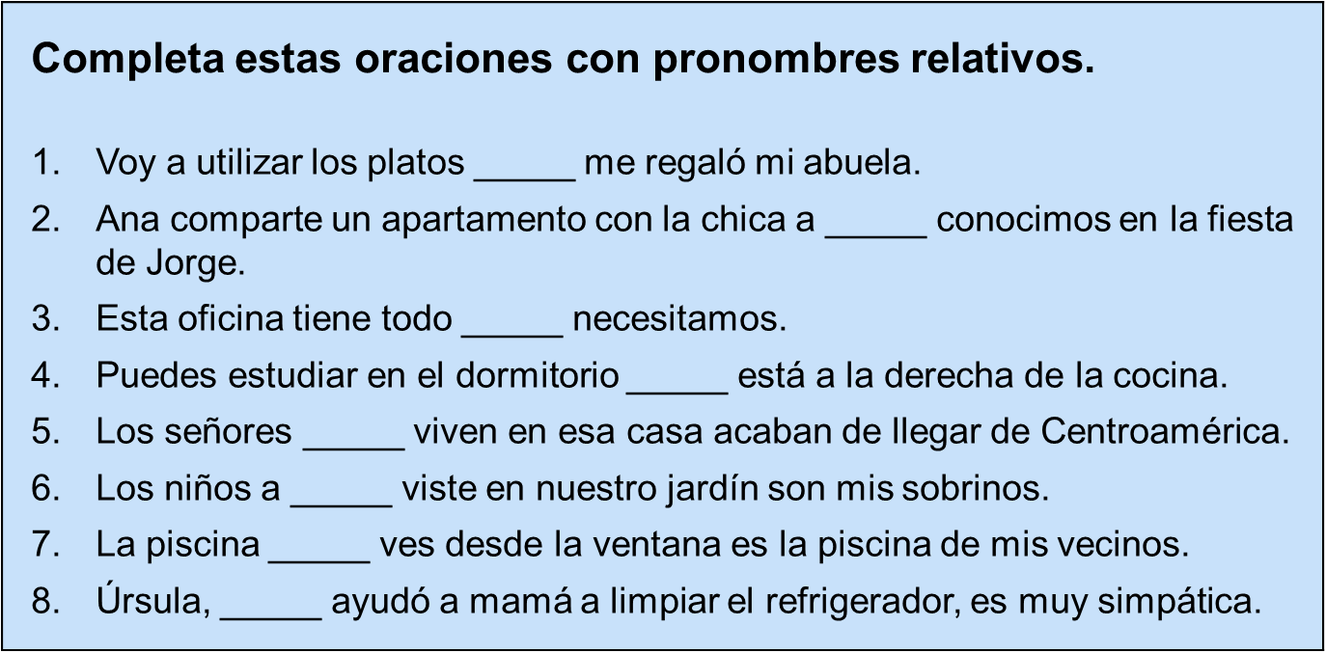
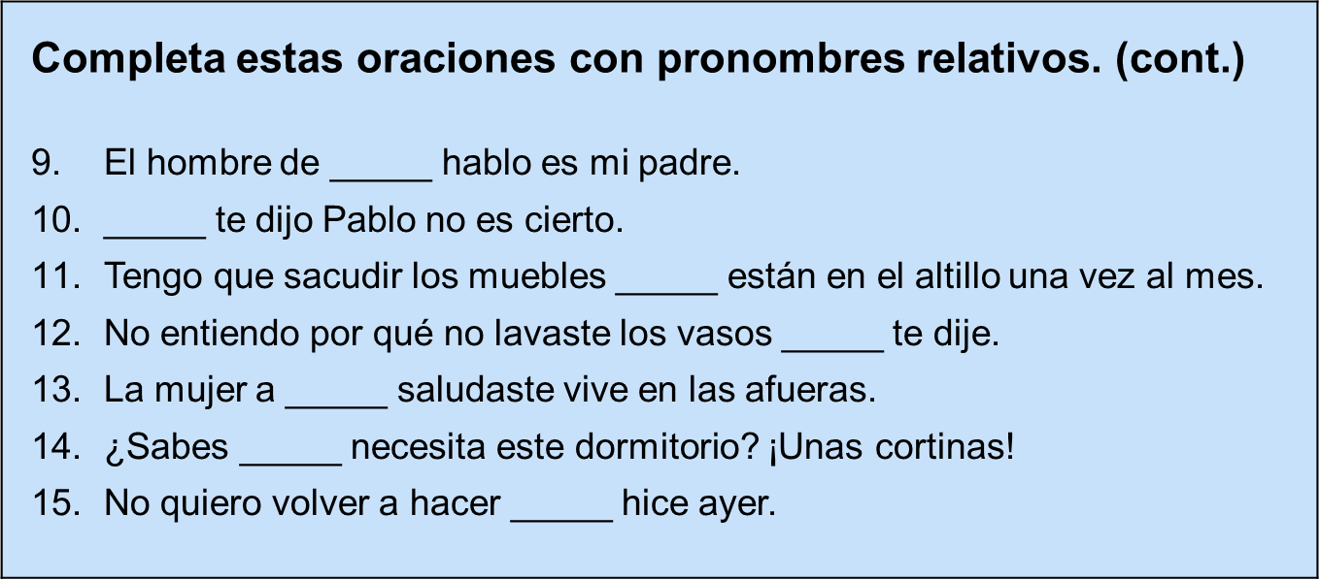

FORMAL COMMANDS: As you learned in Lección 2, the command forms are used to give orders or advice. Formal commands are used with people you address as usted or ustedes. Observe these examples, then study the chart.
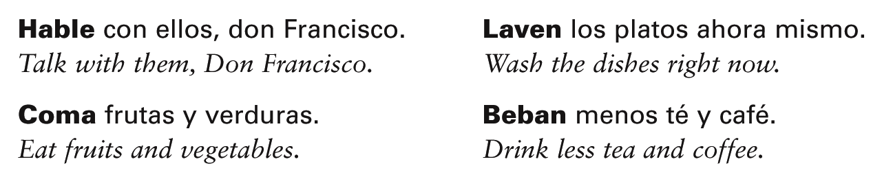
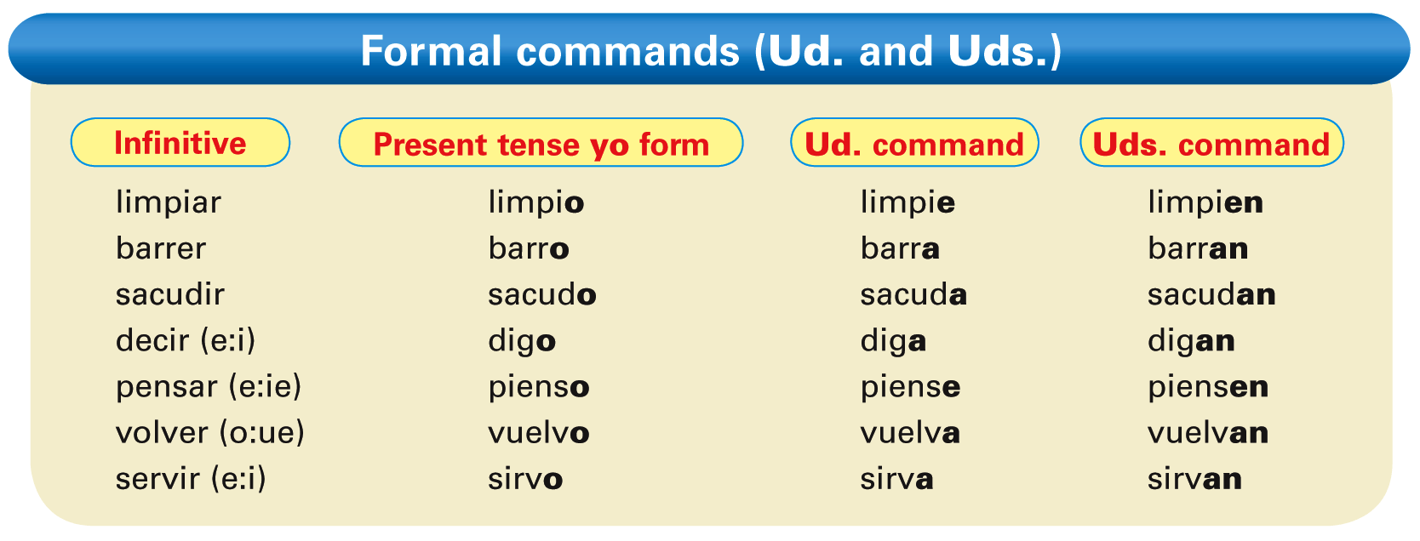
The usted and ustedes commands, like the negative tú commands, are formed by dropping the final -o of the yo form of the present tense. For -ar verbs, add -e or -en. For -er and -ir verbs, add -a or -an.
- Verbs with irregular yo forms maintain the same irregularity in their formal commands. These verbs include conducir, conocer, decir, hacer, ofrecer, oír, poner, salir, tener, traducir, traer, venir, and ver.
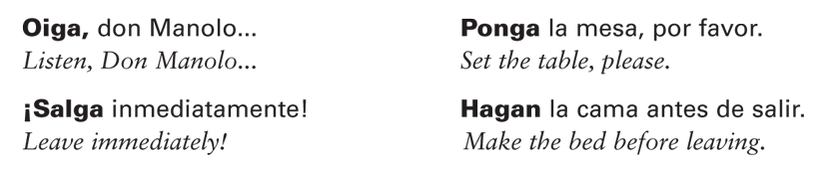
- Note also that verbs maintain their stem changes in usted and ustedes commands.
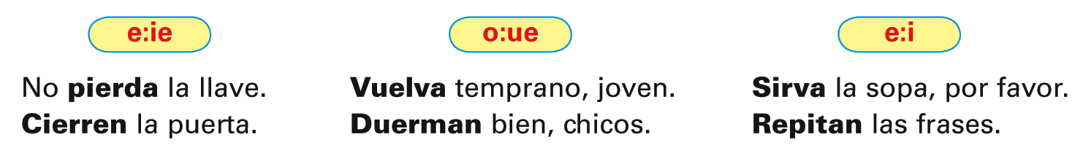
- Verbs ending in -car, -gar, and -zar have a spelling change in the command forms.
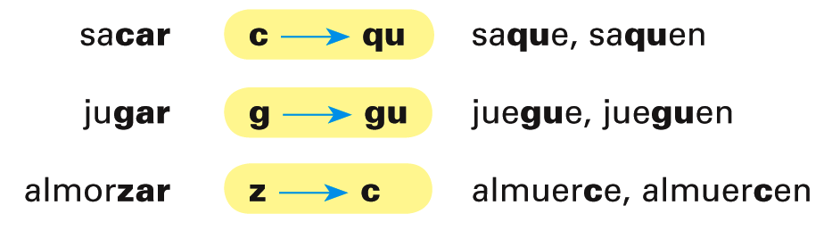

- These verbs have irregular formal commands.
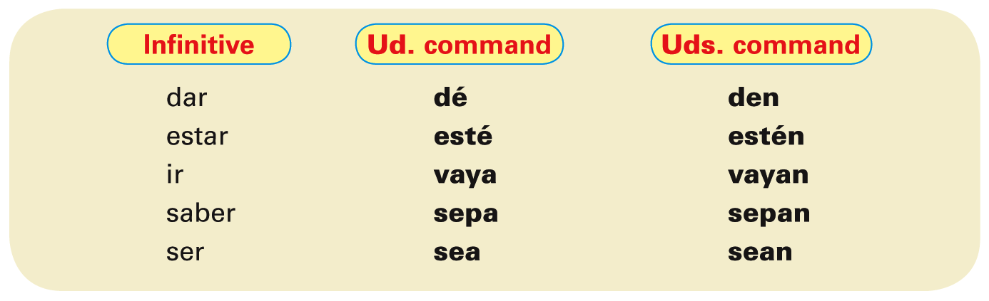
To make a formal command negative, simply place no before the verb.
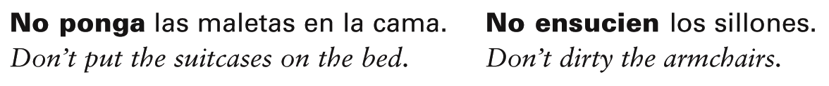
- In affirmative commands, reflexive, indirect, and direct object pronouns are always attached to the end of the verb.
- ¡Atención! When a pronoun is attached to an affirmative command that has two or more syllables, an accent mark is added to maintain the original stress.
- In negative commands, these pronouns always precede the verb.
- Usted and ustedes can be used with the command forms to strike a more formal
tone. In such instances they follow the command form.
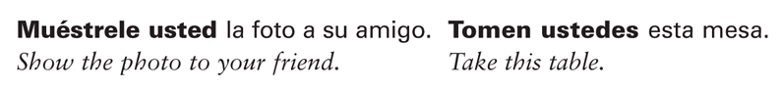
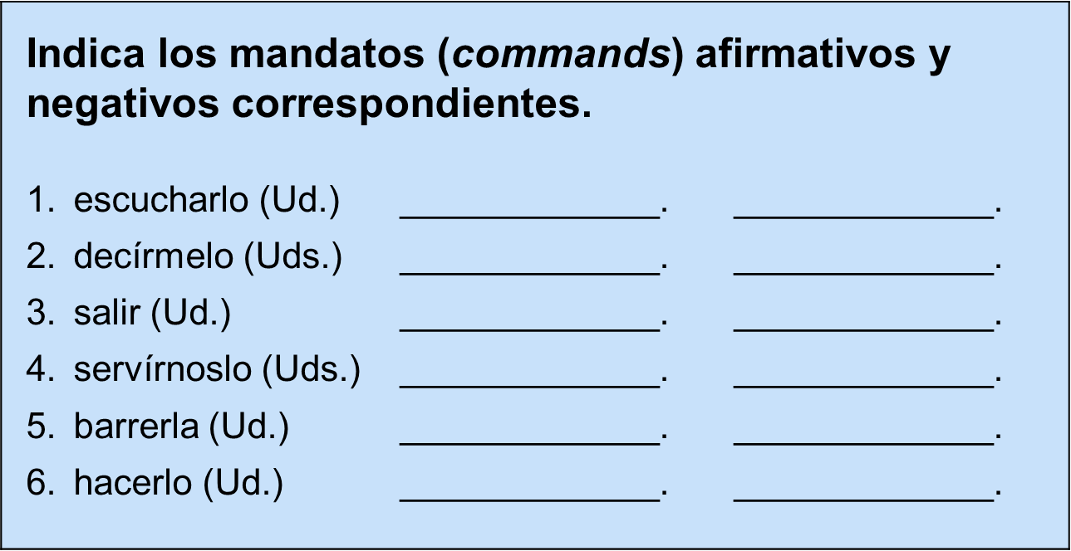

THE PRESENT SUBJUNCTIVE
- With the exception of commands, all the verb forms you have been using have been in the indicative mood. The indicative is used to state facts and to express actions or states that the speaker considers to be real and definite. In contrast, the subjunctive mood expresses the speaker’s attitudes toward events, as well as actions or states the speaker views as uncertain or hypothetical.
- The present subjunctive is formed very much like usted commands, ustedes commands, and negative tú commands. From the yo form of the present indicative, drop the -o ending, and replace it with the subjunctive endings.
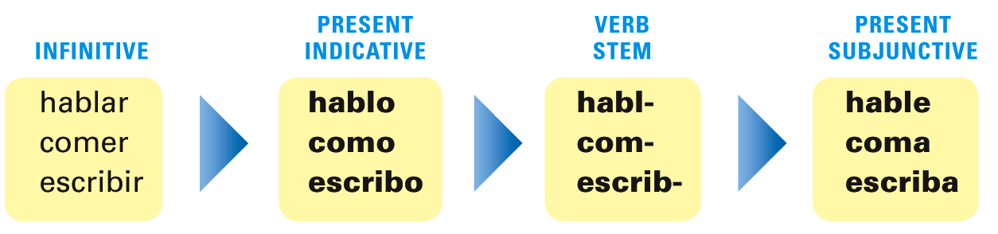
- The present subjunctive endings are:
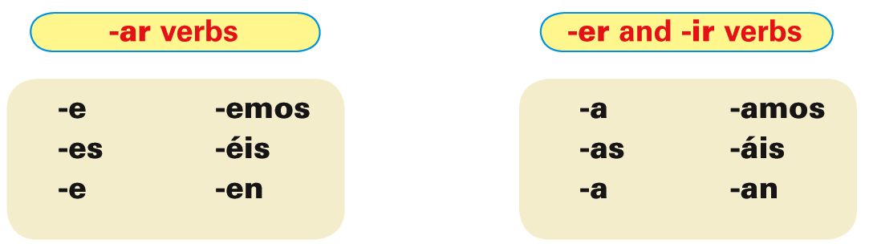
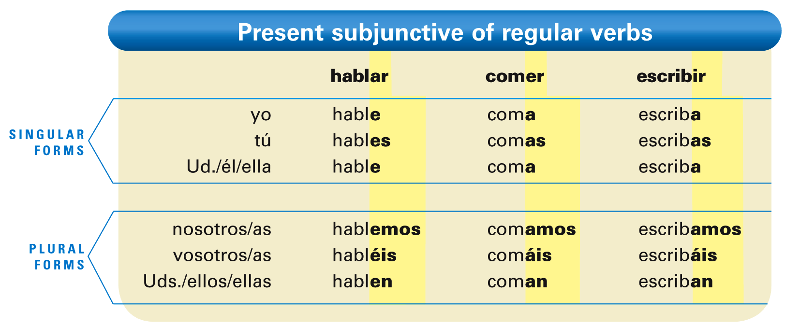
- Verbs with irregular yo forms show the same irregularity in all forms of the present subjunctive.
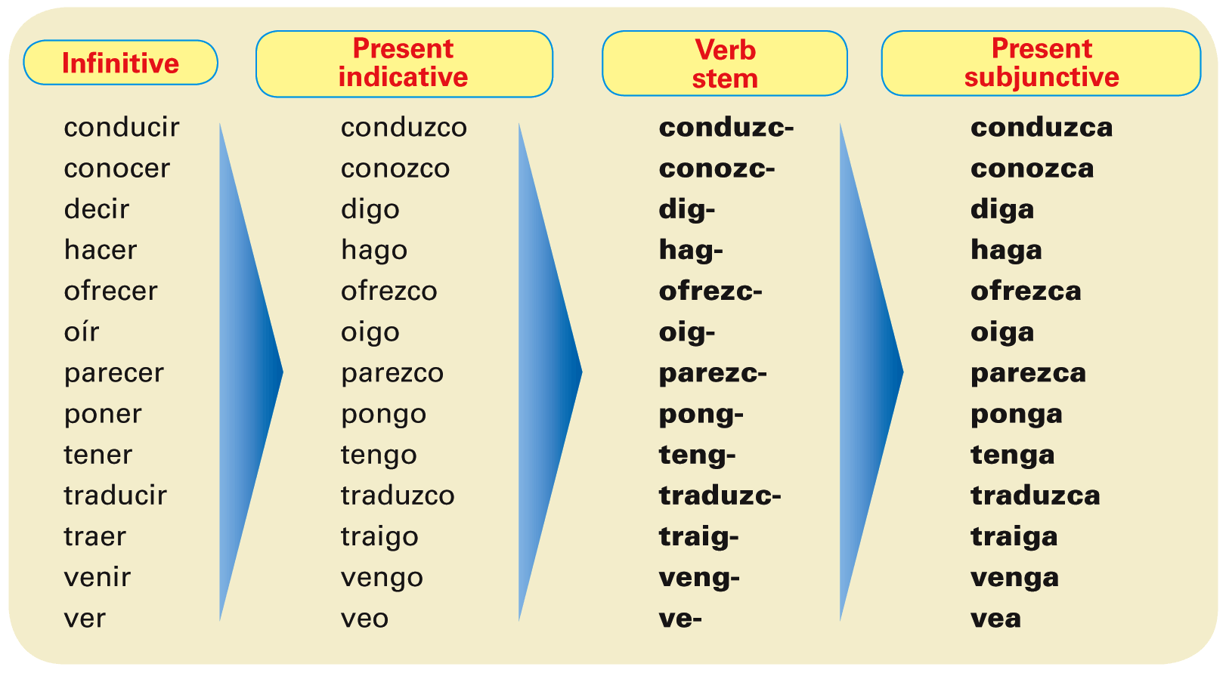
- To maintain the c, g, and z sounds, verbs ending in -car, -gar, and -zar have a spelling change in all forms of the present subjunctive.
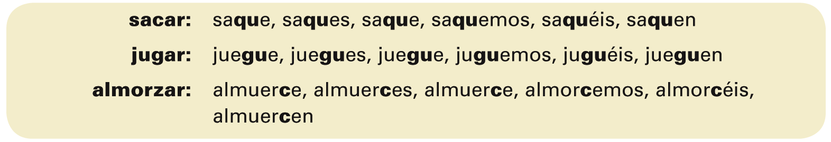
Present subjunctive of stem-changing verbs
- -Ar and -er stem-changing verbs have the same stem changes in the subjunctive as they do in the present indicative.
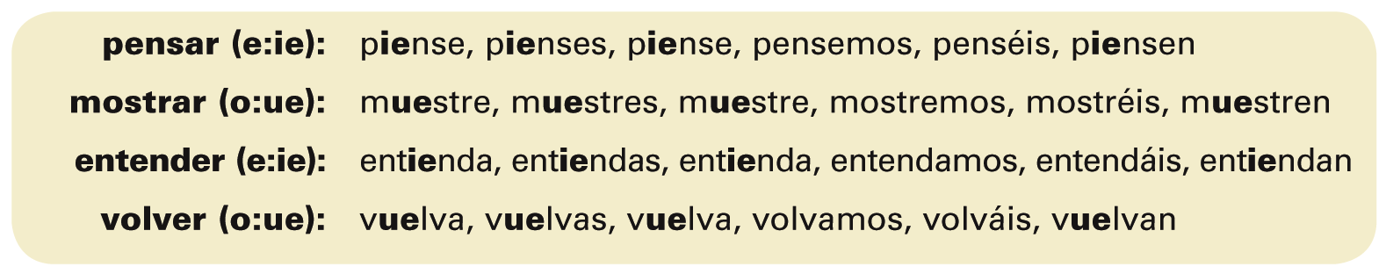
- -Ir stem-changing verbs have the same stem changes in the subjunctive as they do in the present indicative, but in addition, the nosotros/as and vosotros/as forms undergo a stem change. The unstressed e changes to i, while the unstressed o changes to u.
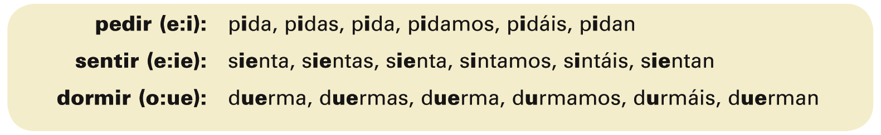
Irregular verbs in the present subjunctive. These five verbs are irregular in the present subjunctive.
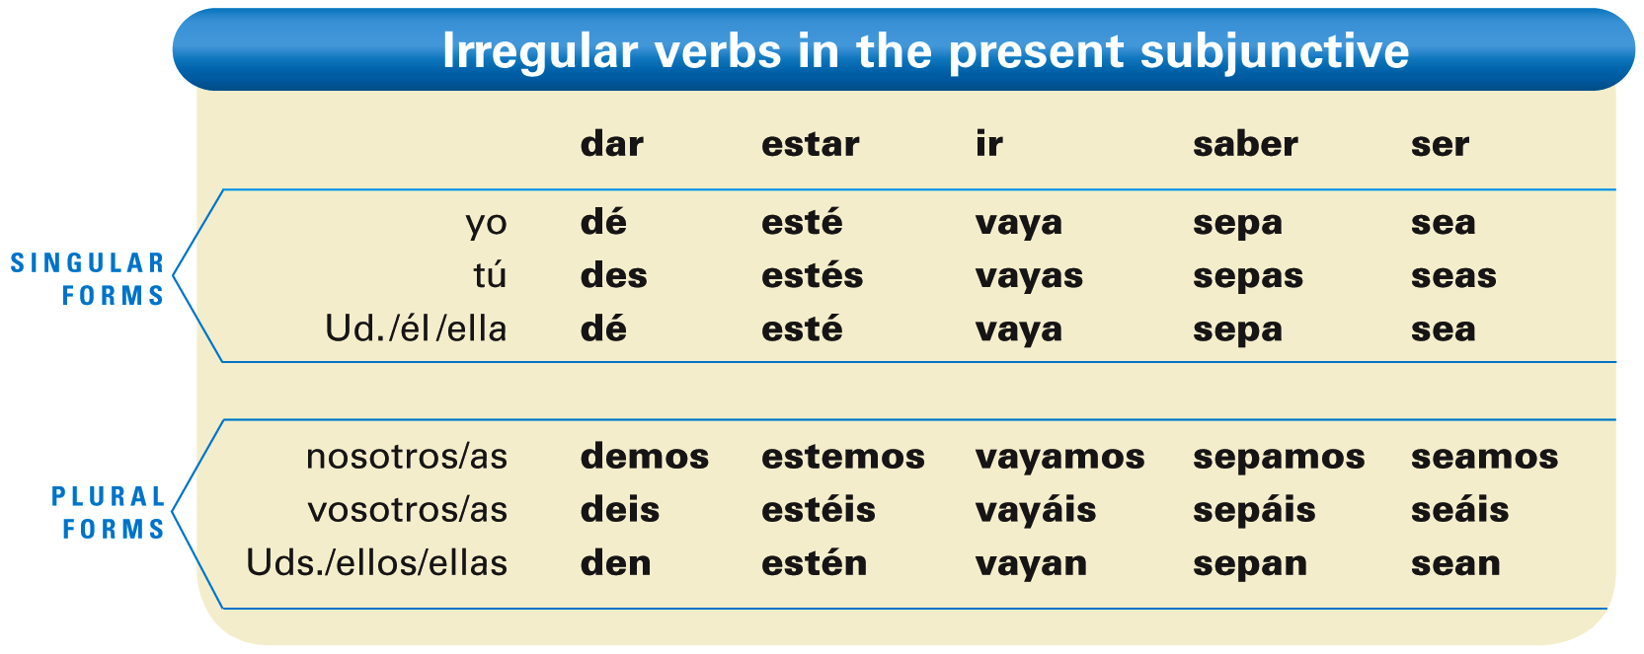
- ¡Atención! The subjunctive form of hay (there is, there are) is also irregular: haya.
General uses of the subjunctive: The subjunctive is mainly used to express: 1) will and influence, 2) emotion, 3) doubt, disbelief, and denial, and 4) indefiniteness and nonexistence. The subjunctive is most often used in sentences that consist of a main clause and a subordinate clause. The main clause contains a verb or expression that triggers the use of the subjunctive. The conjunction que connects the subordinate clause to the main clause.
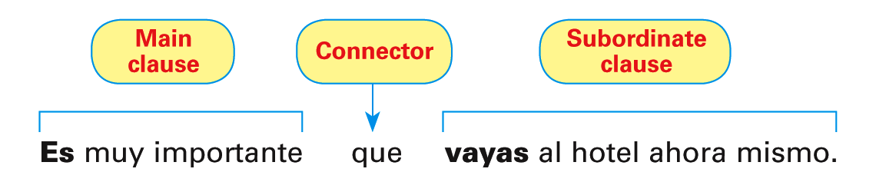
- These impersonal expressions are always followed by clauses in the subjunctive:
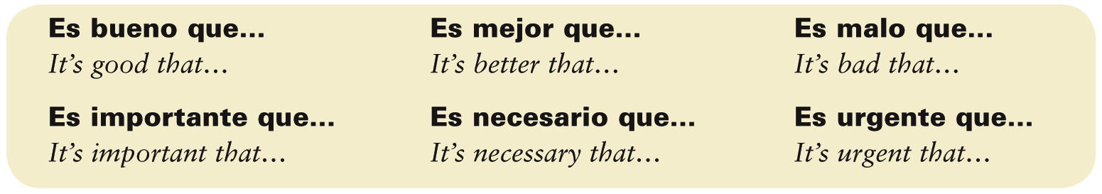
Escribe oraciones usando el subjuntivo con expresiones impersonales.
- Es necesario / yo / beber …
- Es importante / tú / estudiar …
- Es malo / él / dormir …
- Es mejor / nosotras / hacer …
- Es bueno / ellos / poder …
- Es urgente / ustedes / pagar …
- Es importante / yo / saber …
- Es bueno / tú /ser …
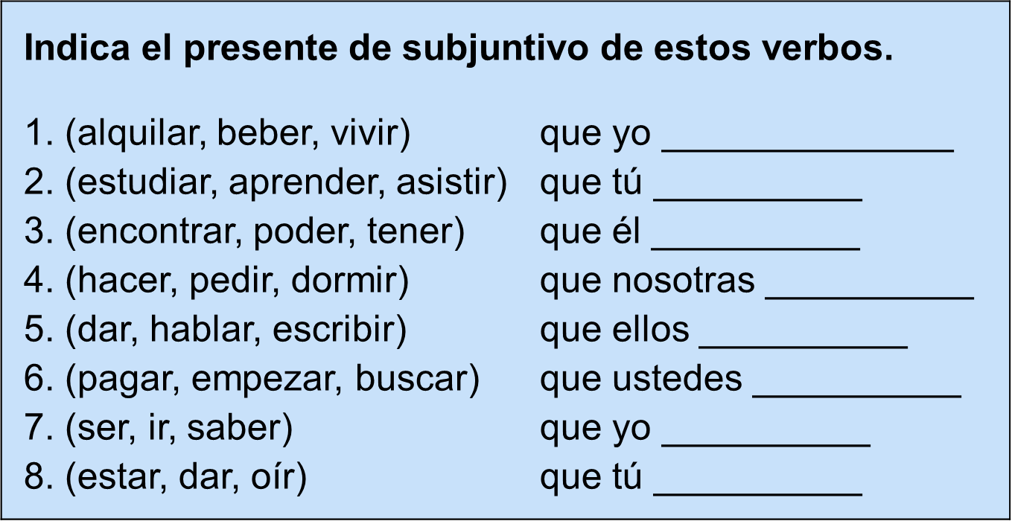
SUBJUNCTIVE WITH VERBS OF WILL AND INFLUENCE
- You will now learn how to use the subjunctive with verbs and expressions of will and influence.
- Verbs of will and influence are often used when someone wants to affect the actions or behavior of other people.
- ¡Atención! In English, verbs or expressions of will and influence often use the infinitive, such as I want you to go. This is not the case in Spanish, where the subjunctive would be used in a subordinate clause. Here is a list of widely used verbs of will and influence.
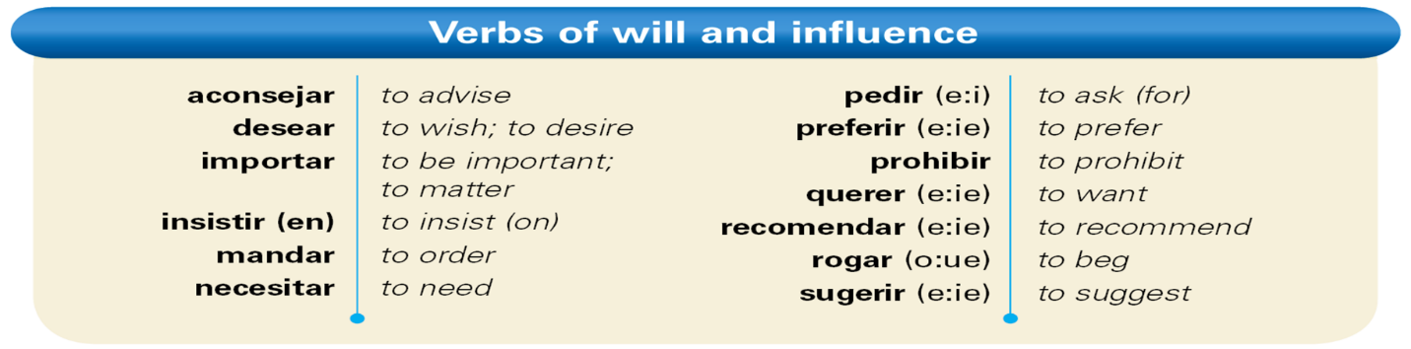
- Some impersonal expressions, such as es necesario que, es importante que, es mejor que, and es urgente que, are considered expressions of will or influence.
- When the main clause contains an expression of will or influence, the subjunctive is required in the subordinate clause, provided that the two clauses have different subjects.
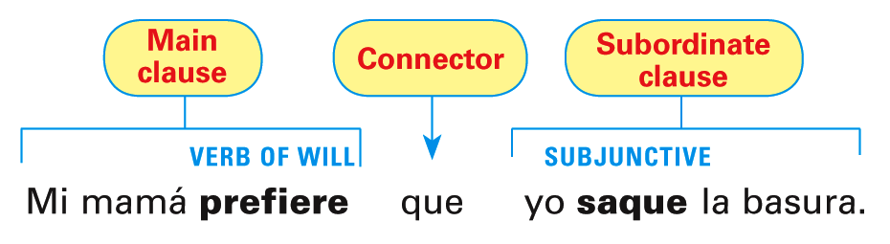
Les sugiero que arreglen el apartamento.
Recomiendo que se organicen en equipos.

- Indirect object pronouns are often used with the verbs aconsejar, importar, mandar, pedir, prohibir, recomendar, rogar, and sugerir.
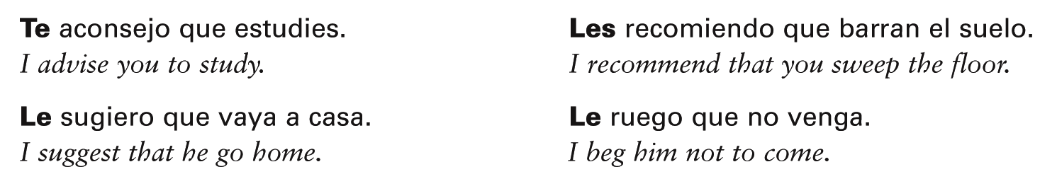
- Note that all the forms of prohibir in the present tense carry a written accent, except for the nosotros/as form: prohíbo, prohíbes, prohíbe, prohibimos, prohibís, prohíben.
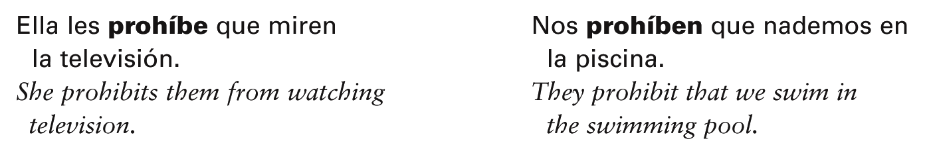
- The infinitive is used with words or expressions of will and influence if there is no change of subject in the sentence.
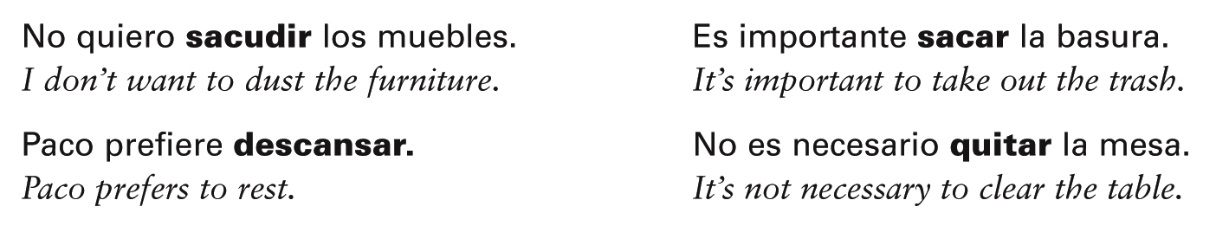
Escribe oraciones usando el subjuntivo con verbos para recomendar o sugerir.
- Yo / sugerir / a ti / ir …
- Tú / querer / yo / hacer …
- Mis padres / insistir en / nosotros / limpiar …
- Los estudiantes / pedir / a la maestro / no dar …
- Mi madre / rogar / a mis hermanos / sacar …

