2.1 MANDATOS INFORMALES
- In Spanish, the command forms are used to give orders or advice. You use tú commands (mandatos informales) when you want to give an order or advice to someone you normally address with the familiar tú.
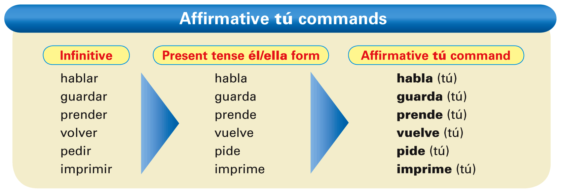
- Affirmative tú commands usually have the same form as the él/ella form of the present indicative.
- The following verbs have irregular affirmative tú commands.
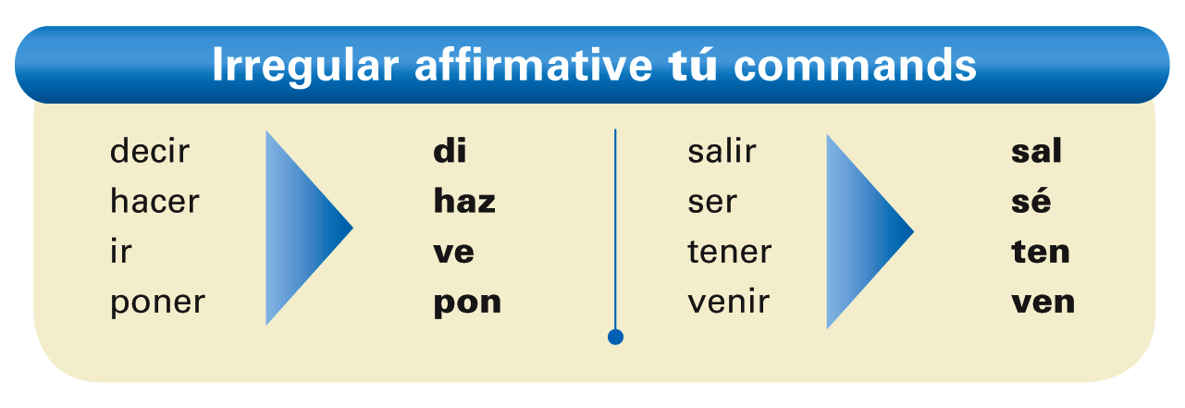
DIVE VENSÉ HAZ TEN PONIES IN HER SALON.
- Since ir and ver have the same tú command (ve), context will determine the meaning.
MANDATOS INFORMALES NEGATIVOS TÚ.
- The negative tú commands are formed by dropping the final -o of the yo form of the present tense.
For -ar verbs, add -es. For -er and -ir verbs, add -as. 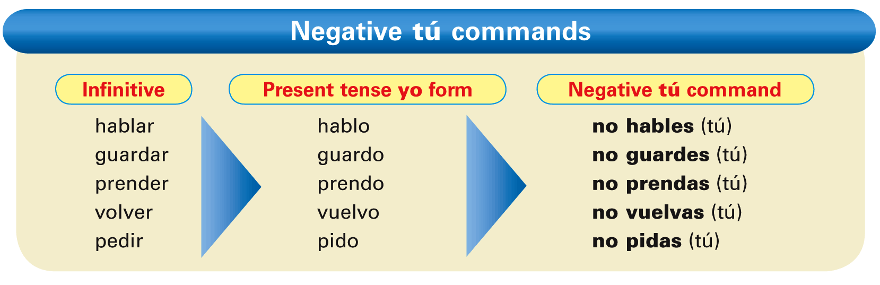
- Verbs with irregular yo forms maintain the same irregularity in their negative tú commands. These verbs include conducir, conocer, decir, hacer, ofrecer, oír, poner, salir, tener, traducir, traer, venir, and ver.
- Note also that stem-changing verbs keep their stem changes in negative tú commands.
- Verbs ending in -car, -gar, and -zar have a spelling change in the negative tú commands.
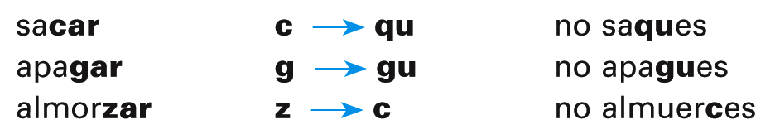
- The following verbs have irregular negative tú commands.
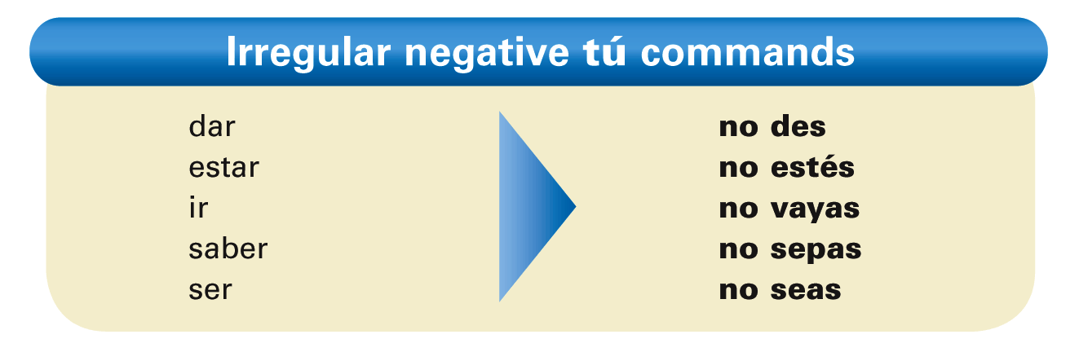
haber no hayas
NO DISHES

- ¡Atención! In affirmative commands, reflexive, indirect, and direct object pronouns are always attached to the end of the verb. In negative commands, these pronouns always precede the verb.
- Bórralos. / No los borres.
- Escríbeles un correo electrónico. / No les escribas un correo electrónico.

2.2 POR Y PARA
- Unlike English, Spanish has two words that mean for: por and para. These two prepositions are not interchangeable. Study the following charts to see how they are used.
- Por and para are most commonly used to describe aspects of movement, time, and action, but in different circumstances.
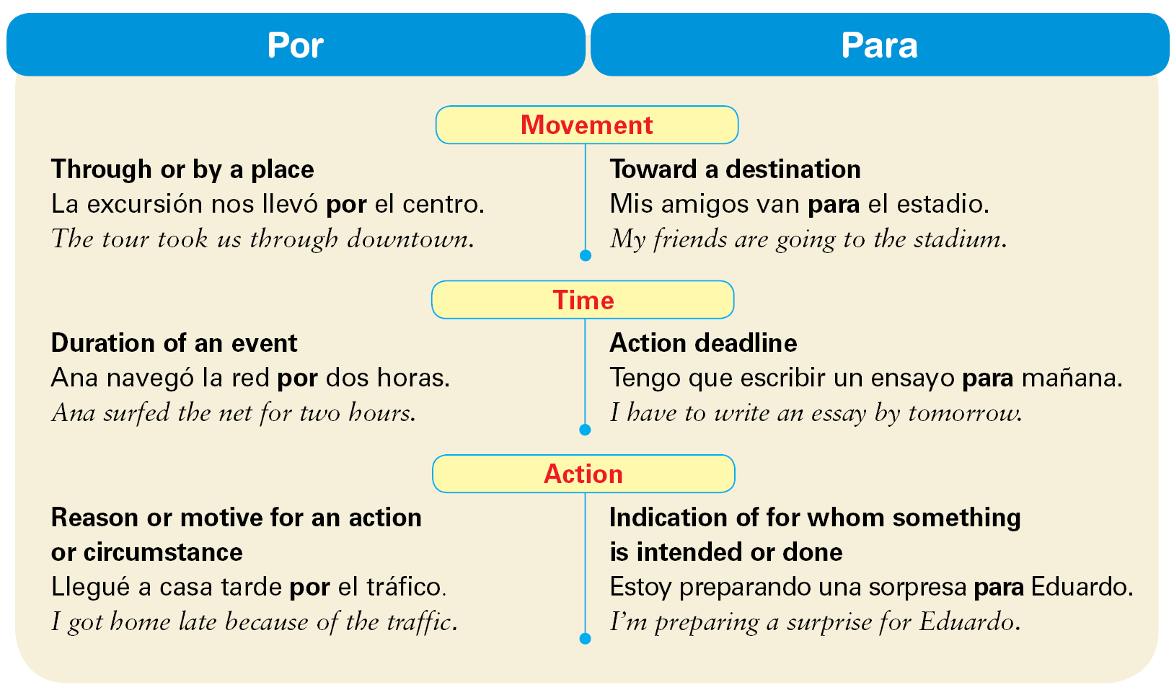
- Here is a list of all of the uses of por and para.
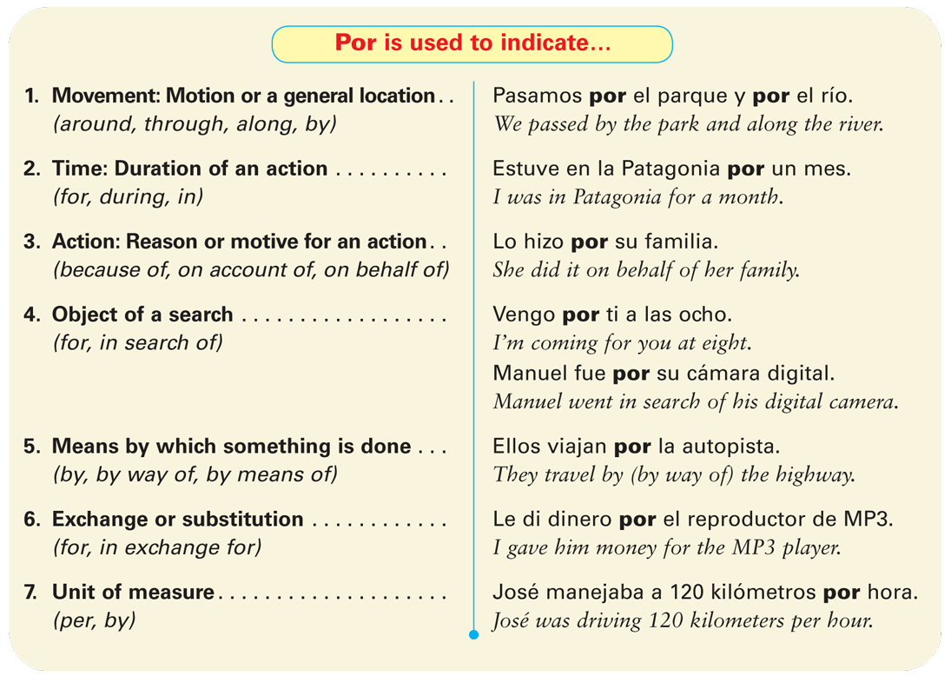
¡Atención! Por is also used in several idiomatic expressions, including:
por aquí around here
por ejemplo for example
por eso that’s why; therefore
por fin finally
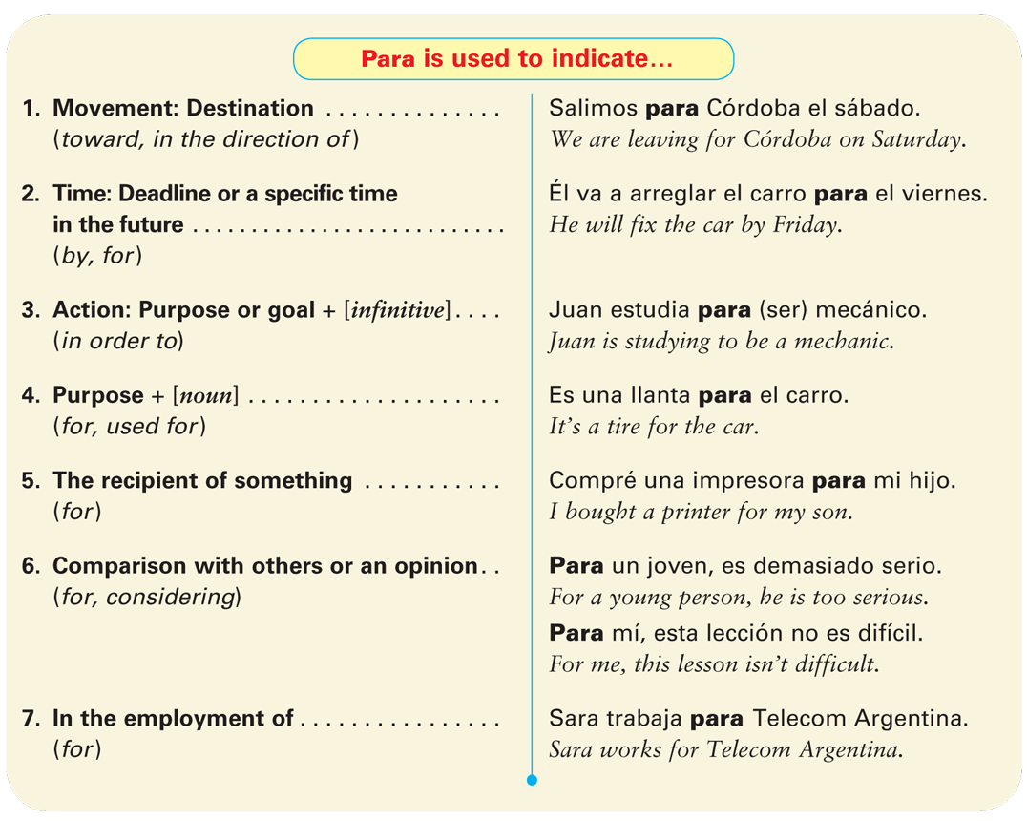
- In many cases it is grammatically correct to use either por or para in a sentence. The meaning of the sentence is different, however, depending on which preposition
is used.
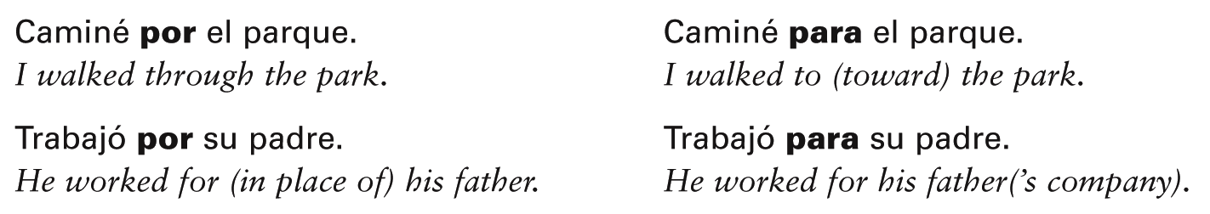
  - VERBOS REFLEXIVOS RECÍPROCOS
You have learned that reflexive verbs indicate that the subject of a sentence does the action to itself. Reciprocal reflexives (los reflexivos recíprocos), on the other hand, express a shared or reciprocal action between two or more people or things. In this context, the pronoun means (to) each other or (to) one another. Only the plural forms of the reflexive pronouns (nos, os, se) are used to express reciprocal actions because the action must involve more than one person or thing.
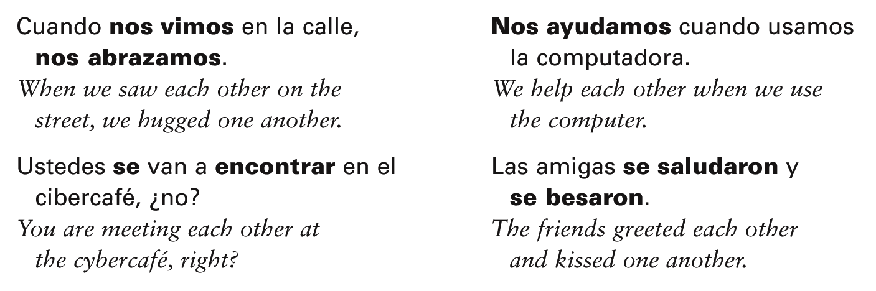
- ¡Atención! Here is a list of common verbs that can express reciprocal actions:
abrazar(se) to hug; to embrace (each other)
ayudar(se) to help (each other)
besar(se) to kiss (each other)
encontrar(se) to meet (each other); run into (each other)
saludar(se) to greet (each other)

2.4 ADJETIVOS Y PRONOMBRES POSESIVOS
- Spanish has two types of POSSESSIVE ADJECTIVES: the unstressed (or short-mi, mis, tu, tus, su, sus, nuestro/a/os/as, vuestro/a/os/as, su, sus) forms you learned in Descubre, nivel 1 and the stressed (or long) forms. The stressed forms are used for emphasis or to express of mine, of yours, and so on.
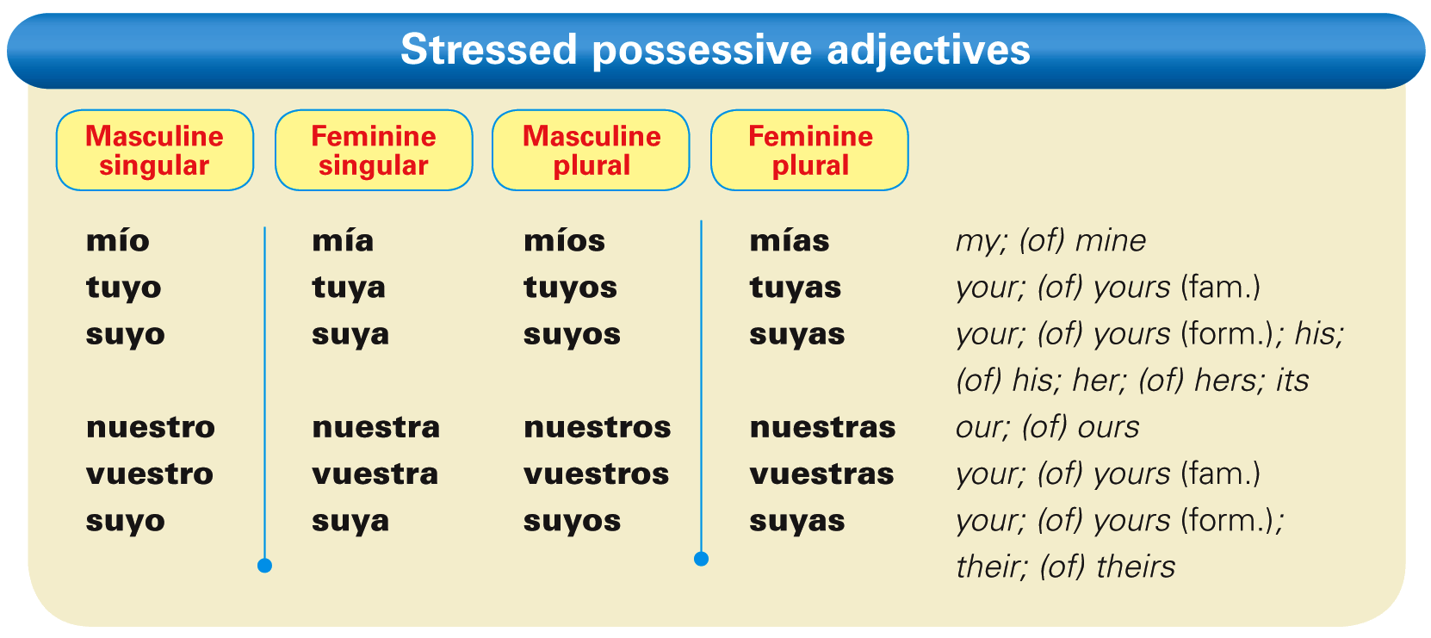
¡Atención! Used with un/una, these possessives are similar in meaning to the English expression of mine/yours/etc.
- Stressed possessive adjectives agree in gender and number with the nouns they modify. While unstressed possessive adjectives are placed before the noun, stressed possessive adjectives are placed after the noun they modify.
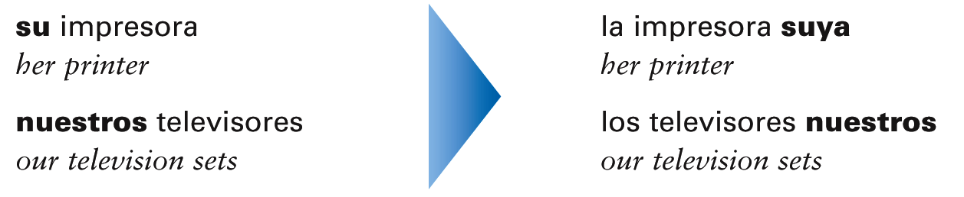

- A definite article, an indefinite article, or a demonstrative adjective usually precedes a noun modified by a stressed possessive adjective.
- Since suyo, suya, suyos, and suyas have more than one meaning, you can avoid confusion by using the construction:
[article] + [noun] + de + [subject pronoun]. 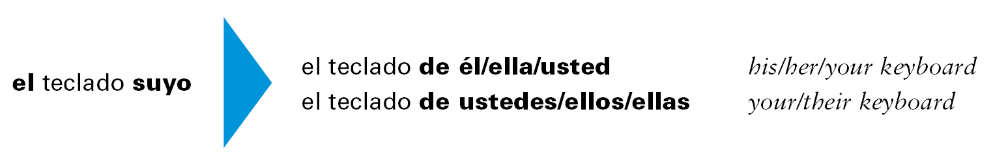
Possessive pronouns
- Possessive pronouns (los pronombres posesivos) are used to replace a noun + [possessive adjective]. In Spanish, the possessive pronouns have the same forms as the stressed possessive adjectives, and they are preceded by a definite article.
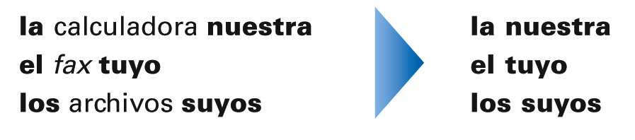
- A possessive pronoun agrees in number and gender with the noun it replaces.
